National Heritage Academies
School Improvement Process Workbook

Student Intervention Services
May 2022

1.0 Overview - SIP Workbook

The school has created this schoolwide plan in order to outline and direct its schoolwide improvement efforts for the 2020 - 2021 school year and beyond. By evaluating and updating this plan, the school will meet state and federal requirements pertaining to schoolwide planning each year.
As part of the school’s Comprehensive Needs Assessment, the school analyzes and disaggregates norm-referenced and criterion-referenced, as well as authentic assessment data, to ensure that all students master academic goals and State standards. The results of the data analysis drive changes (if needed) to the school’s implementation of curriculum, instructional practices, professional development, and the school’s schoolwide plan.

1.1 Schoolwide Plan Introduction
Fill in the table with the planed date for each activity.
School Improvement Process Activities | 2022-23 | 2023-24 | 2024-25 | 2025-26
Comprehensive Needs Assessment & Goal Identification completed | 3/8/22 | 3/8/23 | TBD | TBD
Schoolwide Plan reviewed and updated | 3/8/22 | 3/8/23 | TBD | TBD
Effectiveness of school improvement process in school evaluated | 3/8/22 | 3/8/23 | TBD | TBD
Modifications made to plan based on comprehensive needs assessment and evaluation of effectiveness of SIP efforts | 3/8/22 | 3/8/23 | TBD | TBD
Title I Parent Meetings | 3/8/22 | 3/8/23 | TBD | TBD

2.0 Evidence of Collaboration - GA & LA

Please complete the following chart with your SIP team members (add rows as necessary)
Stakeholder Collaboration Schoolwide plan information is provided to the school’s Board of Directors via Board Meetings and/or additional documented correspondence. Students do not participate on the planning team as the school serves students in grades K-8.
These stakeholders work throughout the year and as the school conducts its formal school improvement activities in order to do the following: - Evaluate the mission statement, parent/family engagement policy*, parent-student compact*, and plan effectiveness - Analyze academic goals, criteria for success, strategies, and action activities in relation to data - Ensure alignment of the curriculum implementation and educational program to State standards in core content areas - Ensure specific objectives are evident in each core content area - Ensure instruction is delivered with appropriate teaching strategies that are based on research and best practice - Monitor the plan as evidenced by regular meetings - Build a comprehensive professional learning plan consistent with student academic performance needs - Identify parent and community resources that enhance instructor and student learning
*Note: Parents also contribute directly to the approval and/or revision of the parent/family engagement policy and the parent-student compact at the Title I Parent Meeting that is held in the spring each school year.

3.0 Collaboration with Teachers and Other School Staff (including Title I staff)

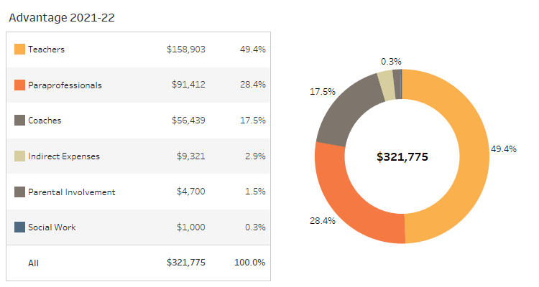
Figure: Grant Allocation Summary

Select a date for your SIP staff meeting.
03/21/2022

4.0 Collaboration with Parents

Select a date for your SIP parent meeting.
03/21/2022

5.0 Collaboration with the School Board

Please enter the date of your Board Meeting at which the SIP will be presented.
01/24/2022

6.0 Comprehensive Needs Assessment - Overview

The school conducts a comprehensive needs assessment annually as part of its continuous improvement process. While data is gathered and evaluated informally throughout each year, the school’s formal needs assessment takes place each spring. The school carried out its school improvement activities in order to identify priority needs and assess overall school and student performance. During this comprehensive needs assessment process, the school assessed data aligned with Department of Education guidelines, which have been established in order to provide schools with a comprehensive improvement structure based on current research and best practices. Specifically, data is collected and assessed as it relates to student achievement, school programs and processes, student/teacher/parent perceptions, and demographics. The school’s review of data includes that which is listed below, among others: - Student achievement on norm-referenced assessments (NWEA PGA and MAP) - Student achievement on criterion-referenced assessments - Student demographics - Discipline, tardy, truancy, and attendance rates - Parent/student perception surveys - Staff surveys, including teacher quality information - Curriculum alignment - Program implementation - Student engagement
The school has also engaged in the following school improvement activities as part of its school improvement process: the identification of particular focus areas within the school’s English Language Arts (ELA) and Math curriculum for each grade level; the development of corresponding grade level action plans; and the implementation of the formative assessment planning process.
The gathering and analysis of such data enables teachers to directly address student learning needs and gauge the degree to which the school-wide, grade-level, and individual student learning goals are being met, as well as provides the means by which comprehensive school improvement efforts are identified. Essentially, this data analysis serves as the primary driver for the school’s decision-making process as it relates to improvement; all goals, objectives, action steps, schoolwide reform strategies, professional development activities, and parent/family/community engagement decisions documented in this schoolwide/school improvement plan are driven by this needs assessment.

7.0 Staff Data

Staff data is collected in order to provide information on trends in staff experience, attendance, HQ status and satisfaction year over year.
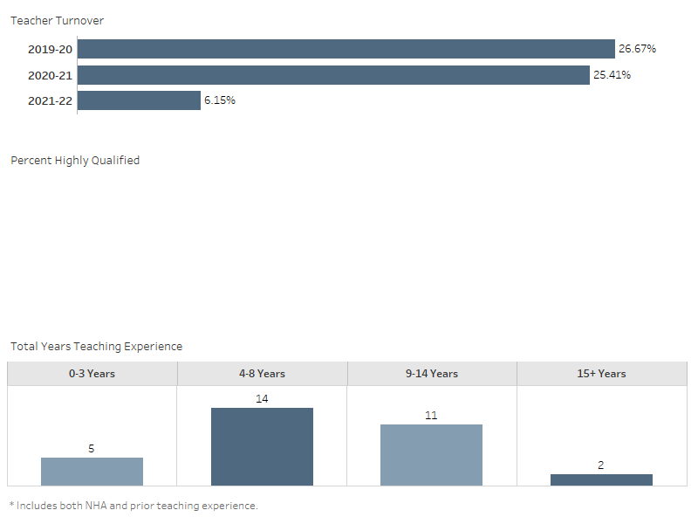
Figure: Teacher Turnover, % Highly Qualified, and Years Teaching Experience

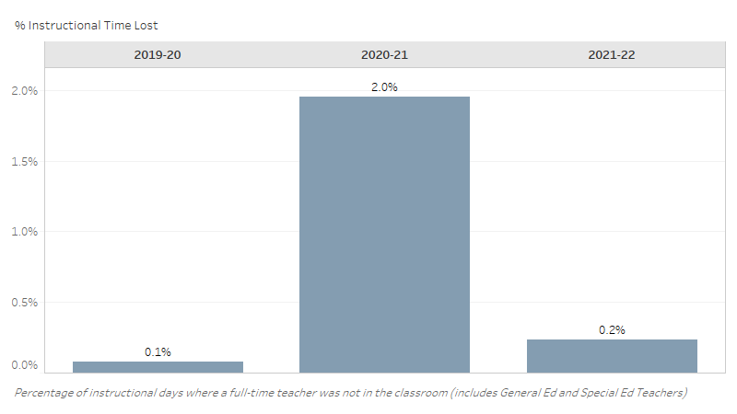
Figure: Teacher Absences and % Instructional Time Lost

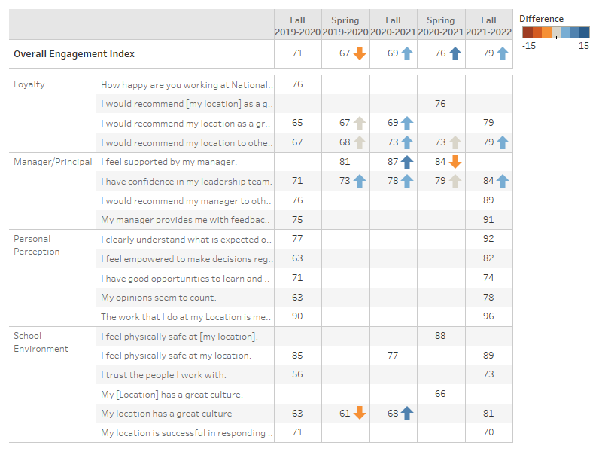
Figure: Staff Perceptions

What trends do you notice in your school staff data?
Advantage went up in all areas for the 2021-2022 school year in comparison to the other years! We are moving in the right direction. We cut down on time and instructional lost and have more qualified teachers in our school building.
Are there action steps you are taking/will take to impact this trend? If yes, what are they?
Yes, the administration team (team one) is working hard to build culture within the school building to ensure our staff members are happy!

8.0 Parent Perception Data

Parent perception data is collected in order to provide information on trends in parent satisfaction year over year.
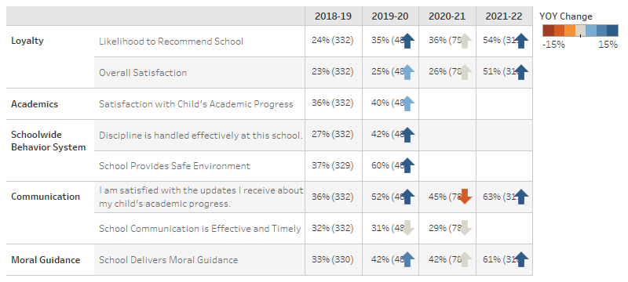
Figure: Parent Survey Results

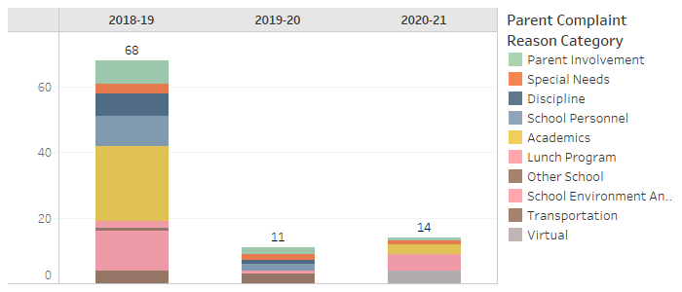
Figure: Parent Complaint Counts

What trends do you notice in your school parent perception data?
I noticed that parents are not satisfied about communication and the rating stayed the same from 2019 to 2020! I'm working to change that area with communicating to our parents and ensuring they are included with decisions.
Are there action steps you are taking/will take to impact this trend? If yes, what are they?
Yes, I'm communicating with our parents every week and including them in our decision making process to better serve their scholars.

9.0 Demographic Data

Student Demographic Data is collected to demonstrate trends in enrollment, attendance, mobility and discipline year over year.
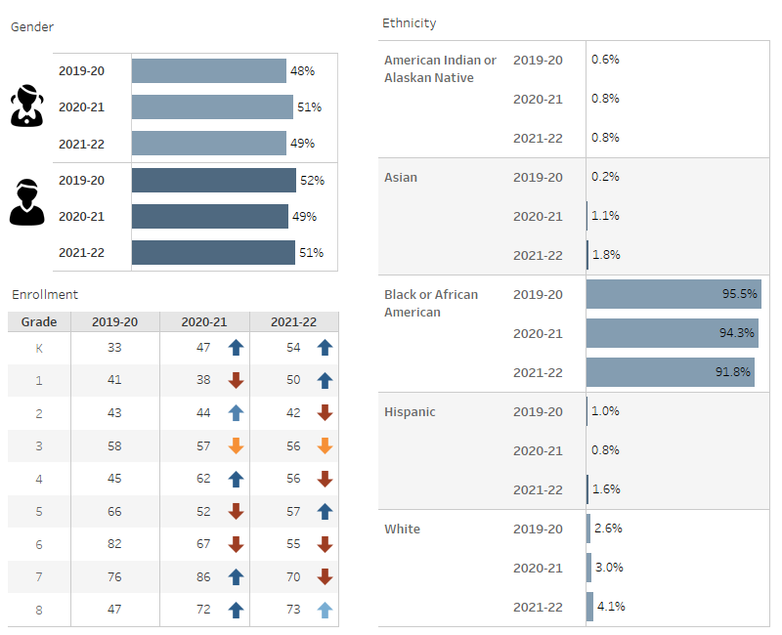
Figure: Gender, Ethnicity, and Enrollment

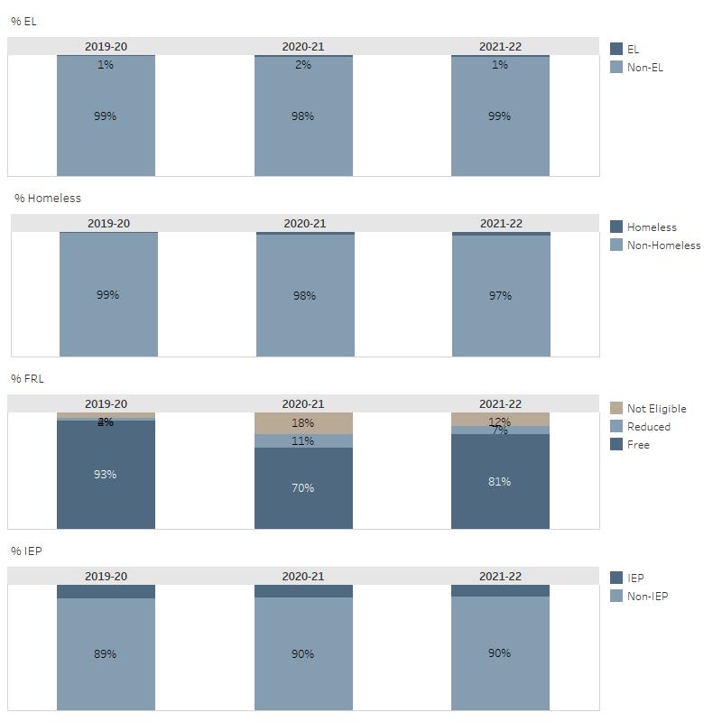
Figure: % EL, % Homeless, %FRL, % IEP

What trends do you notice in your school student demographic data?
In comparison to other years, we are staying the same, nothing really changed with student demographics.
Are there action steps you are taking/will take to impact this trend? If yes, what are they?
Yes, we are promoting Advantage more to attract families from all areas of Baton Rouge.

9.1 Student Attrition Data
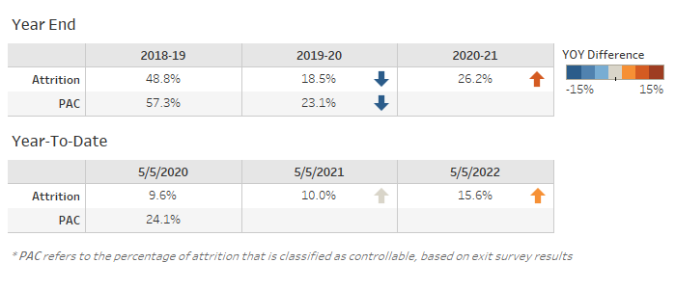
Figure: Student Attrition

What trends do you notice in your school student attrition data?
I notice that Advantage went up in attrition which means we are retaining our current families.
Are there action steps you are taking/will take to impact this trend? If yes, what are they?
Yes, we are ensuring our families are happy by communicating with them often and keeping them in the know! We also engage our students to "love" Advantage by having a safe-positive learning environment.

9.2 Student Attendance
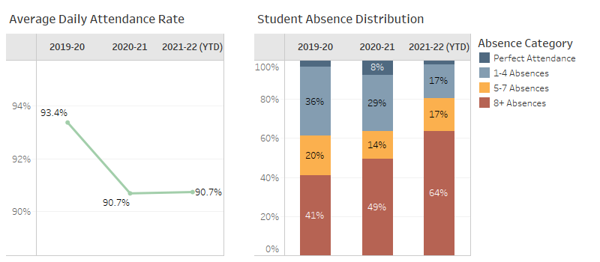
Figure: Student Attendance

What trends do you notice in your student attendance data?
I noticed that we are staying the same but going up in attendance. Attendance is one of those areas where we have to keep working and working! Due to covid at the beginning of the year, we had alot of families out and/or quarantined.
Are there action steps you are taking/will take to impact this trend? If yes, what are they?
Yes, we are holding our families accountable for their scholar's attendance! We are hoping the numbers go down!

9.3 Student Discipline
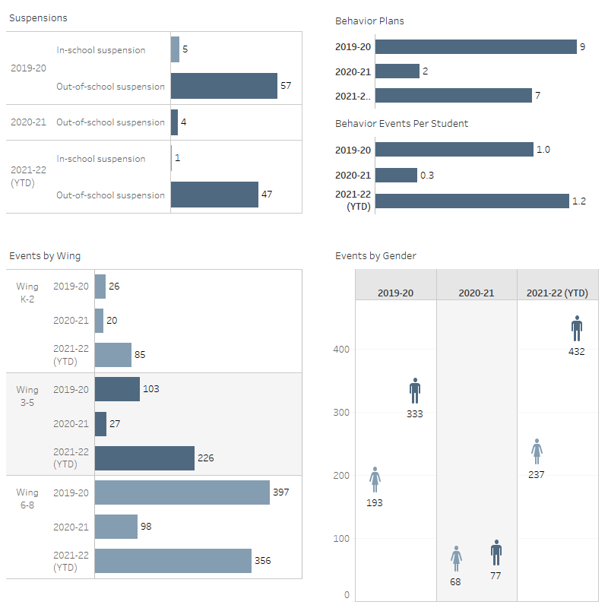
Figure: Suspensions, Events By Wing, Events Per Student, Events By Gender

What trends do you notice in your student discipline data?
I noticed that we went up in logging student's discipline this school year than other years. We have a behavior specialist who is very active and is holding teachers accountable for logging behaviors. The beginning of the school year was a bit rough with behaviors, due to leadership change, but we navigating through those problems to make Advantage a great school.
Are there action steps you are taking/will take to impact this trend? If yes, what are they?
Yes, we are holding students and their parents accountable for their actions.

10.0 School Community Summary

Provide a summary of unique features and challenges associated with the community in which your school resides. Include demographic and economic information.
Our community is located in a urban part of Baton Rouge, where are students are limit to resources. Many of our students are living in a single family home. Our students are not exposed too much in our area. Some economic issues would be our scholars' parents are working and barely making it with what they are bringing home!

11.0 Student Interim Data
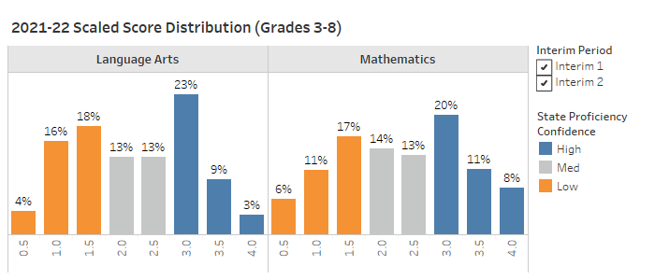
Figure: Interim Scaled Score Distribution

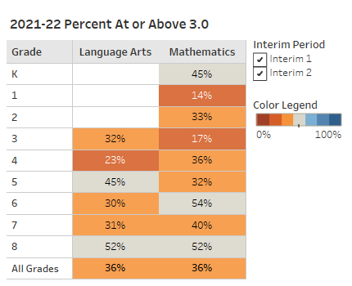
Figure: Interim Percent At or Above 3.0

What trends do you notice in your student interim data?
I noticed we still have work to do, but we are moving in the right direction. Our students are motivated to learn. Math is a higher area in our school building, so we are focusing to move our ELA scores.
Are there action steps you are taking/will take to impact this trend? If yes, what are they?
We have been offering after-school tutoring and Saturday School since November! We also have a program "FEV" tutoring that we offer during the school day for selective students.

12.0 State Test Data
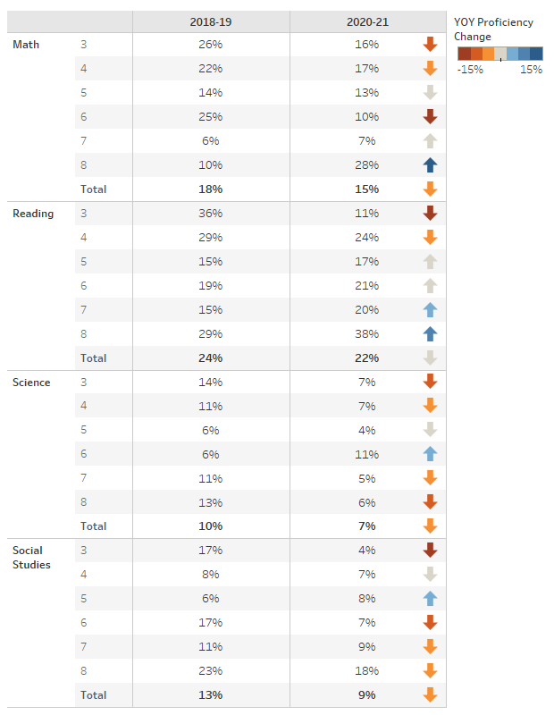
Figure: State % Proficient by Grade

12.1 Subgroup State Achievement Data

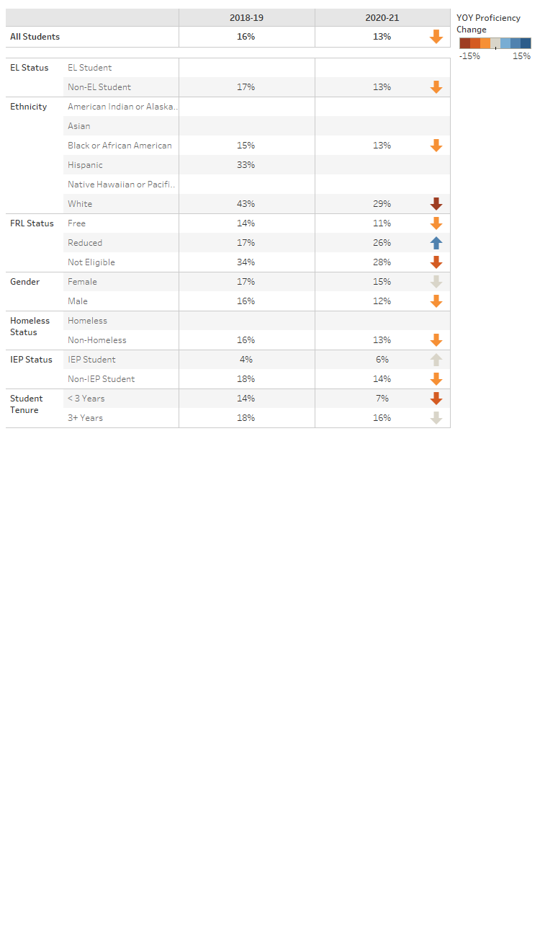
Figure: State % Proficient by Subgroup

What trends do you notice in your student state test data, by grade, by subgroup?
I noticed from the 2018-19 school year to 2020-21 - the data went down in almost all areas and subgroups. Advantage was going through a leadership change during this time, so that could have had an impact on teaching and learning.
Are there action steps you are taking/will take to impact this trend? If yes, what are they?
Yes, we are working to build culture in the building which would impact teaching and learning.

13.0 Comprehensive Needs Summary

Reading
What strengths and challenges in Reading have been identified?
Students are falling below 2-3 grade levels behind in reading, which makes it hard for students to read passages and pass assessments. Some strengths are, when our students begin to read, they are more motivated to learn!
What trends have been identified in Reading?
Some trends are some students are struggling with comprehending, fluency, and vocabulary. Our students are not exposed to reading outside of school.
Are there action steps you are taking/will take to impact this trend? If yes, what are they?
Yes, we have hired more paraprofessionals and a FEV tutoring company to provide intervention to our students! We have also been offering tutoring since November 2021 to enhance our students reading ability. We are diving more into ELA in our building because reading is most definitely a struggle.
Writing
What strengths and challenges in Writing have been identified?
Our students struggle with writing because they are not comprehending the passages. Some strengths are they have learned the state writing rubric, which makes them aware of what they are expected to do!
What trends have been identified in Writing?
Some trends are our students do not answer the prompt in full. They are answering bits and pieces, so we have a writing workshop every Wednesday!
Are there action steps you are taking/will take to impact this trend? If yes, what are they?
Yes, we have a writing workshop on Wednesdays and we are teaching students the writing rubric, so he/she know what is expected of them.
Math
What strengths and challenges in Math have been identified?
Our students are stronger in math than other area in our building! We noticed the students who are struggling in math cannot get through the word problems.
What trends have been identified in Math?
Our students are struggling with word problems.
Are there action steps you are taking/will take to impact this trend? If yes, what are they?
Yes, we are addressing ELA! We also have a math intervention workshop!
Science
What strengths and challenges in Science have been identified?
Science is a challenge because we don't have an appropriate curricular tool that provides our students with a rigorous curricular tool! We are addressing this issue with our DSQ and C&I team.
What trends have been identified in Science?
Trends are not enough resources for Science.
Are there action steps you are taking/will take to impact this trend? If yes, what are they?
We are working with our C&I team and DSQ to get more professional developments and curricular tools to ensure our students are learning in Science.
Social Studies
What strengths and challenges in Social Studies have been identified?
Social Studies is a challenge because we don't have an appropriate curricular tool that provides our students with a rigorous curricular tool! We are addressing this issue with our DSQ and C&I team.
What trends have been identified in Social Studies?
Not enough resources and/or professional developments in Social Studies.
Are there action steps you are taking/will take to impact this trend? If yes, what are they?
We are working with our C&I team and DSQ to get more professional developments and curricular tools to ensure our students are learning in Social Studies.
Student Interventions
How does your school make sure all students learn at a high level?
We are diving more into our interventionist and using them in the appropriate way! Now that we are almost fully staff with interventionist, we can have a true intervention program at Advantage! We are also holding our teachers and students to high expectations with teaching and learning.
How does your school identify students who need intervention?
We identify students who needs intervention through progress monitoring them. If they fall below the 25th percentile in reading, we provide intervention programs to those scholars. In math we use grades and assessments to determine if students need math intervention.
How does your school intervene for students who need the most instruction support (both in the classroom and through intervention programs)?
Each teacher has a 45 minutes intervention block to address students' achievement gap inside the classroom. We also have students who are getting pulled out the classroom for an extra intervention block to address learning lost. We have a "FEV" tutoring program, which provides our students with an one-to-one tutor for 45 minutes during school hours.
How does your school determine if the needs of those students are being met?
We determine if our student needs are being met by assessing and reading fluency. We are consistently reading students data.
How are your teachers involved in analyzing student achievement data to improve the results of all students?
We are consistently looking at the data and releasing data to our teachers. Our data is posted throughout the hallways! Every student and parent know where they are.
Highly Qualified Staff
What does your school do to attract and/or retain high quality teachers (different from the things NHA might do on your behalf)?
We are building culture in our school building to ensure teachers are happy and motivated to teach. We always find a way to appreciate our staff. NHA is a big help with getting us what we need to ensure our staff members are happy!
Staff Professional Development
What staff development offerings were the most effective last year?
Staff developments offerings is regionals. This is where teachers can collaborate with each other!
How do you know the PD was effective?
At the end of the PD our staff members take a survey! We can also tell through their teaching to see what they are taking back to their classrooms.
How will the learning be sustained moving forward?
We will continue regionals and continue to grow our teachers!
What kinds of training or support would benefit your staff this upcoming school year and why?
In-school professional developments. Our ELA and Math teacher collaborates, observe, and learn from each other. This by far has been the best decision we could have made for our teachers. They learn really well from each other and take each other ideas.
Schoolwide Reform Strategies
The school educational program is grounded in the principles of Effective Schools Research, which was originally developed by Ronald R. Edmonds, who served on the faculties of Harvard University and Michigan State University. Effective Schools Research recommends research-based school attributes that are associated with quantifiably improved student learning. By definition, an “Effective School” is one in which all children obtain at least the essential knowledge, concepts, and skills needed to be successful at the next higher level. Within the Effective School, there are seven unique characteristics that correlate with school effectiveness. The school, a public-school academy, has adopted these characteristics as part of its promise to deliver a high-quality educational option for parents of the community. A summary of the Effective School correlates is as follows: - Clear School Mission - High Expectations for Success - Instructional Leadership - Frequent Monitoring of Student Progress - Opportunities to Learn and Student Time-on-Task - Safe and Orderly Environment - Strong Home-School Relations
In addition to adopting these characteristics of Effective Schools Research, the educational program includes a “Back to Basics” approach, a longer school day, and structured discipline, and the curriculum includes a moral focus component based on the Greek cardinal virtues. The educational program utilizes a curriculum that is scientifically research-based, aligned with State standards, and designed to ensure college opportunity for each child that the school serves.
While Effective Schools Research serves as the foundation of the school’s educational program, it has adopted a number of schoolwide reform strategies to ensure that it: - Provides opportunities for all children to meet the State’s proficient and advanced levels of student academic achievement; - Uses effective methods and instructional strategies that are based on scientifically-based research; and - Addresses the needs of all children in the school, but particularly the needs of low-achieving children and those at risk of not meeting the State student academic achievement standards.
One research-based schoolwide reform strategy that the school has adopted is the utilization of a master schedule that provides teachers with opportunities to differentiate instruction in order to meet the varied learning needs of students. According to Tomlinson and Eidson, differentiated instruction “refers to a systematic approach to planning curriculum and instruction for academically diverse learners” and is “a way of thinking about the classroom with the dual goals of honoring each student’s learning needs and maximizing each student’s learning capacity” (2003). The school uses differentiated instruction by implementing regularly scheduled workshop sessions and flexible grouping in order to meet each student’s individual learning needs. The school believes that “only when a student works at a level of difficulty that is both challenging and attainable for that student does learning take place” (Tomlinson, 2003). As such, the school employs differentiated instruction in order to address the needs of all children in the school—particularly those at risk of not meeting challenging State standards.
Another research-based schoolwide reform strategy that the school has adopted is the development of what Richard DuFour calls a Professional Learning Community. Specifically, the school has worked to develop a teaching environment in which all teachers work together to ensure that students learn, where collaboration among teachers is prevalent, and where there is a focus on student learning and results (DuFour, 2004). The school has adjusted its class and teacher schedules to ensure that grade-level teachers share a common planning time in which each member of the instructional team participates in dialogue about student learning and develops strategies to improve both teaching and learning. Mike Schmoker, a leading school improvement thinker, has argued that professional learning communities “feature the most powerful set of structures and practices for improving instruction” (2006). With this in view, the school has implemented these research-based professional learning communities to ensure that teachers are using effective methods and instructional strategies, thereby meeting the needs of all students.
In addition to utilizing differentiated instruction and implementing professional learning communities, the school has also adopted a system that ensures that teachers and students can establish and communicate about student learning goals and track student progress through the formative assessment process. Research supports these schoolwide reform strategies. Specifically, research has demonstrated that “goal setting has a general tendency to enhance learning” (Marzano, 2007). As such, the school believes it is imperative to identify student learning goals, or educational objectives, so that teachers and students can gauge learning with respect to those goals and celebrate student success that they make progress toward mastery. Importantly, because the school is utilizing specific student learning goals- which align with all applicable Department of Education guidelines- teachers can effectively provide feedback on student learning through the use of formative assessment. Marzano points out that “major reviews of research on the effects of formative assessment indicate that it might be one of the more powerful weapons in a teacher’s arsenal” (2007). W. James Popham describes formative assessment as “a planned process in which assessment-elicited evidence of students’ status is used by teachers to adjust their ongoing instructional procedures or by students to adjust their current learning tactics” (2008). Since teachers of the school have well-established student learning goals, they are able to utilize the formative assessment process to track student learning, gauge progress toward mastery, adjust instruction accordingly, and celebrate student success as it relates to learning. Indeed, the employment of these research-based strategies ensures that all students are given the opportunity to learn and succeed in the school’s classrooms.
Finally, the school has adopted as a schoolwide reform strategy the delivery of additional opportunities to learn for students who need to grow in their background knowledge. In Marzano’s seminal meta-analysis of research on school-, teacher-, and student-level factors that impact student achievement, the author argues that there is a strong correlation between background knowledge and student achievement. Where students do not have background knowledge sufficient to ensure academic success, the school works to provide increased opportunities for students to enhance their background knowledge so that their learning can be accelerated; such opportunities may include tutoring, mentoring, vocabulary instruction, and other interventions that ensure students have increased time to learn the knowledge and skills they need to be academically successful. The school’s foundation of Effective Schools Research, coupled with these comprehensive schoolwide reform strategies, is the means by which it ensures that all children are academically successful. Indeed, these strategies enable the school to provide opportunities for all students to progress toward and demonstrate proficiency, and to also ensure college opportunity for each student the school serves.
With these strategies in mind, the school has developed a number of goals to support its effort to ensure that all the school’s students succeed and are able to master State standards. These goals are outlined in the following section of this plan.
Instruction by Highly Qualified Teachers
The school has adopted a hiring practice that requires all new and existing teachers to meet the “highly qualified” requirements as outlined by Every Student Succeeds Act of 2015 legislation. The academy’s management company, National Heritage Academies, tracks teacher qualification status and ensures that teachers achieve and maintain the correct qualifications. All teachers are provided with a fifty percent (50%) tuition reimbursement to either achieve or maintain highly qualified status.
All teachers are currently highly qualified. The school has developed a plan to ensure that it complies with the applicable section of the Every Student Succeeds Act of 2015. The plan outlines the means by which 100% of the school’s staff will reach highly qualified status by the close of the school year.
Strategies to Attract High Quality Teachers
The school will continue to monitor its teacher-turnover rate in order to maintain its commitment to attracting and retaining high-quality, highly qualified teachers. The school will continue to monitor its teacher-turnover rate in order to maintain its commitment to attracting and retaining high-quality, highly qualified teachers. The school holds as a top priority the recruiting, hiring, and retaining of high quality, highly qualified, and fully licensed teachers to serve its students. Efforts made by the school and its management partner, National Heritage Academies, include the following: - Establishing close relationships with local universities and colleges with teacher education programs. - Yearly attendance at college teacher specific job fairs. - Internal teacher job fair events sponsored by National Heritage Academies. - Advertising positions through online college postings, newspaper advertisements, the National Heritage Academies website, and a weekly internal job newsletter that is sent out to all school and NHA employees. - Offering a competitive salary and benefits package, including fifty percent (50%) reimbursement benefit for continuing education. - Providing a comprehensive orientation that facilitates a successful transition into teaching. - Providing opportunities for teachers to improve their instructional skills through a comprehensive professional development program. - Including teachers in the continuous improvement planning process, and other school initiatives and activities.
The school has developed a plan to ensure that it complies with all applicable sections of the Every Student Succeeds Act of 2015. Research indicates that one of the most significant initiatives schools undertake to retain staff is to create a team-based collaborative culture within the school. The focus at the school on grade level teams and on having teachers as active members of the improvement team, serves to ensure that the school achieves greater consensus, collaboration, and cooperation throughout the school. This should be an asset in ensuring that the teacher turnover rate remains low.

14.0 Wellness Policy and Goal Evaluation

The National School Lunch Act mandates that all schools participating in the National School Lunch Program and/or School Breakfast Program establish a Wellness Policy and general requirements for the development, implementation, dissemination and assessment of the policy and evaluate it annually.
Has progress been made on the Wellness Goals?
Yes, we changed lunch
Do you think the Wellness Policy and goals are positively impacting student wellness, nutrition, and regular physical activity?
Yes, I do, but the students do not eat lunch
In your opinion, does the Wellness Policy need to be changed? If so, what would you change?
I'm not sure if it needs to be changed, but better lunch needs to be served to our students.
What changes, if any, do you think are necessary to be made to the Wellness goals?
Maybe a better lunch for our students or more options.

15.0 School Improvement Goals
Action Plan for Continuous Improvement
Goal | Building Culture
Baselne Data | Glint survey
Area of Need | Motivating teacher at Advantage
Root Cause | Teachers may not feel appreciated
Strategies | Making our teachers feel appreciated
Activities/Action Steps the School will Implement as Part of the Overall Strategy for Continuous Improvement and Meeting Goal/Objective.
Name | Activity Type | Action Steps | Begin Date | End Date | Staff Responsible | Funding | Measurement of Progress | Goal Status | Notes

Goal | Ensuring our students are learning
Baselne Data | LEAP, interim, and assessment data to ensure students are growing and prepared for the state assessment
Area of Need | Providing on-going professional developments to our teachers
Root Cause | Not enough training for our staff members
Strategies | Continue to building our staff instructional knowledge through professional development
Activities/Action Steps the School will Implement as Part of the Overall Strategy for Continuous Improvement and Meeting Goal/Objective.
Name | Activity Type | Action Steps | Begin Date | End Date | Staff Responsible | Funding | Measurement of Progress | Goal Status | Notes

16.0 Evaluation of School Improvement Efforts

How does your school evaluate the effectiveness of your goals and strategies each year?
We look at data to ensure students are growing
In reviewing the goals from last year's SIP, provide an overview/evaluation of progress made toward those goals. Was progress made toward accomplishing the goal? If so, will you a) Continue the goal? b) Discontinue the goal, if so why?
Yes, we are moving in the right direction at Advantage!

17.0 Professional Learning Plan

In accordance with ESSA, the academy provides high-quality and ongoing professional learning for teachers, principals, and paraprofessionals and, if appropriate, pupil services personnel, parents, and other staff to enable all children in the school to meet the state's student academic achievement standards.
The school plans to carefully integrate its professional learning for the staff—for both teachers and paraprofessionals—into its collaborative team-focused culture and its ongoing teacher supervision and support model. The cornerstone of that model is the grade level team arrangement which provides daily opportunities for common planning/professional learning time for the grade level teams within the regular school days as well as regularly scheduled vertical house/full faculty meetings outside of the school day.
Consider the data you have gathered and carefully identify and prioritize your professional learning needs.
Date | Content Hours | Title | Objectives | PD Type (Required, Grants, or General Funded) | # of Estimated Attendees | Intended Audience
August 2nd to 6th | 40 | Regional | To ensure teachers have the tools needed before the beginning of the school year | Required | 75 | All staff members
October 25th | 8 | Staff PD in house | Ongoing learning | Required | 76 | All staff members
January 3rd | 8 | Staff PD in house | Ongoing learning | Required | 76 | All staff members
February 11th | 8 | Regional | Ongoing learning | Required | 76 | All staff members

18.0 Community Partnerships

The school utilizes a variety of partnerships to support staff, students, and parents. The school employs an Admissions Representative who works in partnership with the community to organize events, fundraisers, and charity events, as well as to inform the media and local community of school events. Additionally, the school partners with area organizations or community members in order to promote a symbiotic relationship between itself and the community.
Please complete the sections below for each partnership that your school has developed and include specific details as appropriate.
Partner Name | Benefits of Partnership
Music Orchestra for Kids | Our students get to explore music with this company, bringing something different to Advantage
CIS - Teaching Sex Ed | We teamed up with our Communities in School person to teach sex-ed to our students with his/her parent permissions. This is much needed with our generation of students.
Baker Police Department | The police department assist us with building culture for staff and students. They usually provide us with great cookouts, etc.. All funds provided by them!

19.0 Parent and Family Engagement Plan and Activities Calendar

The school believes that parents are an integral part of the school and student success. As such, the school has designed a governance structure and parental engagement activities in order to ensure that parents participate in the activities of the school. The school desires parents to be engaged in their child’s education, and the partnership of parents, students, and teachers within the school promotes an optimum learning environment to ensure success. The school’s Parent and Family Engagement Policy and the Parent-Student Compact agreement are used in the school’s Title I program to ensure that parents have the opportunity to provide input in Title I programming and participate in the improvement process. The school’s parents are also asked to complete the school’s Annual Title I Parent Survey; information from that survey is reviewed as part of the school’s comprehensive needs assessment and the evaluation of the school’s Schoolwide Plan.
In accordance with ESSA, the school reviews and distributes the Parent-Student Compact to parents during parent-teacher conferences, during which time the compact is discussed as it relates to individual student performance and the participation and commitment of the parent, teacher, and child in the child’s education.
Complete the calendar below by listing details for your planned parent engagement activities for next year.
Month | Engagement Activity
September 2022 | Title I Parent Meeting (includes review/feedback of School Improvement Plan, Parent Involvement Policy, Commitment to Excellence Contracts, Homeless Dispute Resolution and Title I programming)
October 2022 | Title I Parent Learning Event (i.e. Reading Night, Math Night, etc.)
November 2022 | Fall Parent/Teacher Conferences (includes review of Commitment to Excellence Contracts)
March 2023 | Parent SIP Meeting
April 2023 | Spring Parent/Teacher Conferences

Through these activities and parental/family engagement components, the school assures that it appropriately: 1) provides assistance to parents/families; 2) provides materials and training to help parents/families work with children to improve their achievement; 3) trains teachers and other required staff in the importance of and how to partner with parents/families; 4) coordinates and integrates to the appropriate degree its parent and family engagement activities with other programming; 5) communicates information related to school and parent programs and activities are communicated in an understandable format and language; and 6) provides full opportunities for parents/families with limited English proficiency, disabilities, and parents of migratory children to be involved in the activities of the school and to receive appropriate information and school reports. As such, it complies with ESSA.
Parental and family engagement activities, and the parent/family engagement component of this schoolwide plan, will be involved in the annual evaluation of the schoolwide plan. Feedback from parents provided through communication and their participation in the evaluation process will be incorporated into the review process and the school improvement plan and programs will be adjusted accordingly.
Additionally, results of individual student academic assessments will be discussed with parents regularly and, as appropriate, will be shared in a language that parents/families can understand. As such, the school complies with Section 1113(b)(3).
Preschool Transition Strategies
The school is committed to connecting with preschool age children in order to prepare them for school and has developed preschool transition strategies to ensure that incoming students are well-prepared for kindergarten.
Specifically, the school has a dedicated Admissions Representative who works with area preschools, daycares, Head Start programs, etc., in ensuring kindergarten readiness. The school’s Admissions Representative and Administrators meet with community members and preschools to discuss Preschool Transition. Meetings consist of informing parents about the school, inviting parents and students to visit the school and kindergarten classrooms, inviting preschool/daycare staff to visit the school and the kindergarten classrooms, and a training/delineation of information regarding the skills and knowledge students will need to know when they enter the kindergarten classroom. Training/informational packets, which are delivered to parents and area preschools/daycares, contain information about kindergarten readiness, activities to prepare children for kindergarten, and commonly asked questions regarding the transition from preschool to kindergarten.
Further, open-house meetings and events are held at the school over the course of the year in order to encourage area parents and preschoolers to spend time at the school. Kindergarten teachers meet with parents and students, explaining some of what parents and students should expect as the children make the transition into kindergarten.
Teacher Participation in Making Assessment Decisions
Teachers at the school play an active role in making assessment decisions for their students. Specifically, teachers choose to implement as appropriate tests and assessments that measure student performance with respect to the school’s curriculum. Through the formative assessment planning process, teachers work collaboratively with respect to the curriculum in order to identify what specific knowledge or skills students need to know and also to identify how they will determine when such learning has taken place. Teachers participate in the decision-making process regarding whether they use curricular program assessments, common grade-level assessments, or other formative or summative assessments to determine or gauge student learning on an ongoing basis throughout the year. Instruction is adjusted accordingly by each teacher as they work to ensure mastery is attained by each student within their classroom and at the school.
Additionally, schools administer the NWEA assessment. After the NWEA testing period, grade level teams analyze and interpret NWEA data in order to identify areas of strength and areas for improvement with respect to their students. These activities support the school’s overall school-wide student achievement goals (as outlined above) and are used to drive classroom instruction. Teachers create formative and summative assessments to gauge students’ progress regarding these areas for improvement. During common planning time, teachers discuss and analyze assessment data and determine the degree to which students have mastered the content that has been taught.
Assistance to Students Having Difficulty Mastering Standards
The school has implemented activities to ensure that students who experience difficulty mastering standards are provided with effective and timely additional assistance. Additionally, the school has developed measures to ensure that students' difficulties are identified on a timely basis in order to provide teachers and school leadership with sufficient information on which to base effective assistance.
As noted above, teachers utilize formative assessment to meet the varied learning needs of students. The school uses differentiated instruction by implementing regularly scheduled workshop sessions and flexible grouping in order to meet each student’s individual learning needs. The school believes that “only when a student works at a level of difficulty that is both challenging and attainable for that student does learning take place” (Tomlinson, 2003).[1] As such, it employs differentiated instruction in order to address the needs of all children in the school and particularly those at risk of not meeting challenging State standards. As part of this differentiation, teachers use the formative assessment process to ask and answer these questions: 1) What do we want each student to learn? 2) How will we know what each student has learned? and 3) How will we respond when students have difficulty learning? By answering these questions collaboratively, teachers ensure that appropriate intervention is delivered to students who are having difficulties mastering challenging state standards.
Beyond this, the school’s instructional staff collaborates with its Interventions Assistance Team (IAT), which works to identify students having academic or behavioral difficulties. Students who are in danger of having difficulty mastering the State’s academic achievement standards are first identified by the individual teacher’s assessment process, and then students are referred to the IAT. Classroom teachers are provided by the IAT with suggested intervention strategies to implement with individual students. Such strategies sometimes include, but are not limited to: - Adapting time allotted for learning task or completion of assessment - Adapting the number of items that the learner is expected to complete or learn - Adapting the goals or outcome expectations while using the same materials - Adapting the way instruction is given to the learner. For example: visual aids, hands on activities or cooperative groups.
Teachers log interventions used with the individual students and share the results with the school’s IAT team as appropriate.
Additional supplemental interventions are offered for at risk students. Some of these supplemental interventions may include: - Supplemental Staffing (i.e. paraprofessionals, academic specialist, and social worker). - Supplemental subscriptions (BrainPop, Study Island, Accelerated Reader) for intervention programming. - Extended Learning Opportunities, including summer learning programming and before school tutoring. - The use of researched-based, formative assessment to track and analyze individual student progress and drive instruction that is aligned with highly specific reading curriculum, state content standards and grade-level expectations. - Keep track of students’ progress, at least every two weeks, in specified classes - Monthly examination of student work by classroom teacher related to classes. - The use of Formative Assessment to plan instruction that will target areas of weakness, proficiency and mastery.
Coordination and Integration of Federal, State, and Local Services and Programs
The school ensures that the use of all federal, state, and local funds is coordinated to ensure focus on the goals, strategies, and action activities identified in this Schoolwide Plan. Furthermore, coordination and integration of all federal, state, and local services and programs are ensured through collaboration among administration, staff, parents, and other stakeholders as part of the school’s improvement planning process. Specifically, the school utilizes funds from State and local sources, as well as federal sources—including Titles I and IIA—to support the goals identified in the Schoolwide Plan. While funding will not be consolidated, the school’s entire educational program is supported by the school’s Schoolwide Plan; this includes the school’s general educational program (State and local funds) as well as supplemental programs (supported through federal Title I funds). The school’s professional development program, supplemented with funding available through Titles IIA, is also supported by the academy’s Schoolwide Plan. Although the school is not required to delineate the funds that it is consolidating or the specific amounts contributed by each source—because it is not actually consolidating funds—please see the table below for a summary of the resources available to the school and the degree to which they support the components within this Schoolwide Plan.
Since the school is a single school K-8 public school academy, it does not currently apply for or receive violence prevention funds, housing program funds, Head Start funds, adult education funds, vocational and technical education funds, or job training funds. If the school receives these funds at any point in the future, their use will be coordinated along with all other available funds through the school’s Schoolwide Plan.
While the school receives funds through the National School Lunch Act / Child Nutrition Act, their use is not coordinated under this plan as they do not contribute directly toward upgrading the school’s educational program.
Curriculum Alignment
The school implements the National Heritage Academies Curriculum. National Heritage Academies is the school’s management company and has gone to extensive lengths to create a guaranteed and viable curriculum. NHA has researched the level of knowledge and skills students must have to be successful in terms of mastering State standards as well as being prepared for a challenging college program. This has included analyzing data from the NAEP (National Assessment of Educational Progress), ACT (American College Testing), and Northwest Evaluation Association’s (NWEA) in order to determine what students must know in order to be successful in college. By understanding the required knowledge base to succeed at the college level, NHA was able to work backwards and breakdown this knowledge base at each grade level. This breakdown allows for a seamless building of knowledge which will best prepare our students for high school and college. They utilized these findings and state standards to create the curriculum, ensuring the curriculum is aligned to and meets state requirements.
Additionally, the refinement of the curriculum was completed in collaboration with Dr. Robert Marzano and Associates and teachers are working toward the full implementation of formative and summative assessment as proposed by Dr. Marzano.
While the school utilizes the NHA Curriculum to guide instruction, it also understands how that curriculum aligns with State content standards. When the State’s content standards require students to demonstrate knowledge or skills beyond or different from the NHA Curriculum, the school utilizes supplemental curricular tools and resources to ensure that students are fully equipped to demonstrate mastery according to the State’s expectations.
Methods of Effective Use of Technology
The school utilizes technology in a variety of ways to support student learning. Some of these may include Accelerated Reader, Lexia, Brian Pop and Raz Kids, which are each used to improve the academic achievement of all students. Additionally, the school uses myNHA to record attendance, discipline reports, and grades to inform instruction and remediation. All staff and students have internet access in order to research educational topics and ensure technology proficiency among students. Likewise, all staff members communicate via e-mail and voicemail to increase parent awareness and student progress.
On-the-Job Learning
Since the school is a K-8 school that emphasizes a “back-to-basics” curriculum, on-the-job opportunities in a career sense are limited. However, the school does have a strong character education or moral focus component within its curriculum, and in that context, students are expected to serve others via specific service projects that are undertaken at each grade level. Additional on-the-job learning opportunities include: - Safety Monitor - Crossing Guard - Peer Mentoring - Junior Achievement - Career Day - Student Government - College and Career Fair
Building Level Decision Making
Decision Making Process:
Decision-making authority within the school lies with the school’s leadership team, although the school values and considers the input and perspective of staff and stakeholders as decisions are made. Each staff member and stakeholder’s input is valuable, and decisions become effective only once consensus is achieved among them. Decisions support the vision and purpose of the school, National Heritage Academies, and also the best practices of school improvement research and effective teaching strategies. Staff members and stakeholders participate as appropriate as members of the school operating committees in partnership with the parents.
Job Description of the School Improvement Team:
The school has a School Improvement Team that is responsible for the school improvement efforts of the school. Its job is to conduct the school’s comprehensive needs assessment, analyzing student and other data in order to establish appropriate goals and strategies to reduce achievement gaps as identified in the annual gap analysis and adequate yearly progress reviews. The School Improvement Team also reviews and assists in the development, implementation, and evaluation of the following school improvement components: - Annual review of the Building Mission Statement - Building goals, strategies, and assessments based on academic standards for all students - Curriculum alignment with State Standards and Benchmarks, NHA Curriculum, and Core Knowledge objectives - Monitor and evaluate the process for the building school improvement plan - Building professional development plans consistent with student academic performance needs - The utilization of community resources and volunteers - Participatory decision-making process - Identifying community resources that enhance instructor and student learning
The School Improvement Planning Team meets regularly to assess progress on and accomplishment of goals and implementation of the various components of the Schoolwide Plan.

