National Heritage Academies
School Improvement Process Workbook

Student Intervention Services
June 2022

1.0 Overview - SIP Workbook

The school has created this schoolwide plan in order to outline and direct its schoolwide improvement efforts for the 2020 - 2021 school year and beyond. By evaluating and updating this plan, the school will meet state and federal requirements pertaining to schoolwide planning each year.
As part of the school’s Comprehensive Needs Assessment, the school analyzes and disaggregates norm-referenced and criterion-referenced, as well as authentic assessment data, to ensure that all students master academic goals and State standards. The results of the data analysis drive changes (if needed) to the school’s implementation of curriculum, instructional practices, professional development, and the school’s schoolwide plan.

1.1 Schoolwide Plan Introduction
Fill in the table with the planed date for each activity.
School Improvement Process Activities | 2022-23 | 2023-24 | 2024-25 | 2025-26
Comprehensive Needs Assessment & Goal Identification completed | 4/30/23 | 4/30/24 | TBD | TBD
Schoolwide Plan reviewed and updated | 9/30/23 | 9/30/24 | TBD | TBD
Effectiveness of school improvement process in school evaluated | 6/30/23 | 6/30/24 | TBD | TBD
Modifications made to plan based on comprehensive needs assessment and evaluation of effectiveness of SIP efforts | 3/31/22 | 3/31/23 | TBD | TBD
Title I Parent Meetings | 3/28/22 | 3/28/23 | TBD | TBD

2.0 Evidence of Collaboration - NY

Please complete the following chart with your SIP team members (add rows as necessary):
Stakeholder Collaboration
Schoolwide plan information is provided to the school’s Board of Directors via Board Meetings and/or additional documented correspondence. Students do not participate on the planning team as the school serves students in grades K-8.
These stakeholders work throughout the year and as the school conducts its formal school improvement activities in order to do the following: - Evaluate the mission statement, parent/family engagement policy*, parent-student compact*, and plan effectiveness - Analyze academic goals, criteria for success, strategies, and action activities in relation to data - Ensure alignment of the curriculum implementation and educational program to State standards in core content areas - Ensure specific objectives are evident in each core content area - Ensure instruction is delivered with appropriate teaching strategies that are based on research and best practice - Monitor the plan as evidenced by regular meetings - Build a comprehensive professional learning plan consistent with student academic performance needs - Identify parent and community resources that enhance instructor and student learning
*Note: Parents also contribute directly to the approval and/or revision of the parent/family engagement policy and the parent-student compact at the Title I Parent Meeting that is held in the spring each school year.

3.0 Collaboration with Teachers and Other School Staff (including Title I staff)

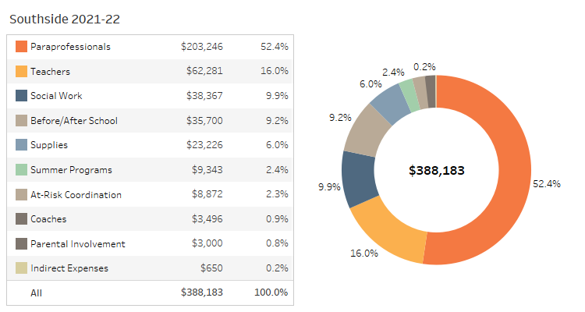
Figure: Grant Allocation Summary

Select a date for your SIP staff meeting.
03/24/2022

4.0 Collaboration with Parents

Select a date for your SIP parent meeting.
03/30/2022

5.0 Collaboration with the School Board

Please enter the date of your Board Meeting at which the SIP will be presented.
03/08/2022

6.0 Comprehensive Needs Assessment - Overview

The school conducts a comprehensive needs assessment annually as part of its continuous improvement process. While data is gathered and evaluated informally throughout each year, the school’s formal needs assessment takes place each spring. The school carried out its school improvement activities in order to identify priority needs and assess overall school and student performance. During this comprehensive needs assessment process, the school assessed data aligned with Department of Education guidelines, which have been established in order to provide schools with a comprehensive improvement structure based on current research and best practices. Specifically, data is collected and assessed as it relates to student achievement, school programs and processes, student/teacher/parent perceptions, and demographics. The school’s review of data includes that which is listed below, among others: - Student achievement on norm-referenced assessments (NWEA PGA and MAP) - Student achievement on criterion-referenced assessments - Student demographics - Discipline, tardy, truancy, and attendance rates - Parent/student perception surveys - Staff surveys, including teacher quality information - Curriculum alignment - Program implementation - Student engagement
The school has also engaged in the following school improvement activities as part of its school improvement process: the identification of particular focus areas within the school’s English Language Arts (ELA) and Math curriculum for each grade level; the development of corresponding grade level action plans; and the implementation of the formative assessment planning process.
The gathering and analysis of such data enables teachers to directly address student learning needs and gauge the degree to which the school-wide, grade-level, and individual student learning goals are being met, as well as provides the means by which comprehensive school improvement efforts are identified. Essentially, this data analysis serves as the primary driver for the school’s decision-making process as it relates to improvement; all goals, objectives, action steps, schoolwide reform strategies, professional development activities, and parent/family/community engagement decisions documented in this schoolwide/school improvement plan are driven by this needs assessment.

7.0 Staff Data

Staff data is collected in order to provide information on trends in staff experience, attendance, HQ status and satisfaction year over year.
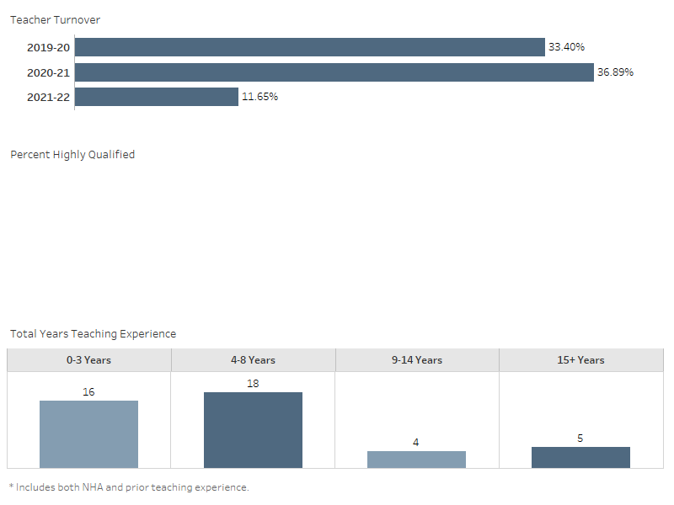
Figure: Teacher Turnover, % Highly Qualified, and Years Teaching Experience

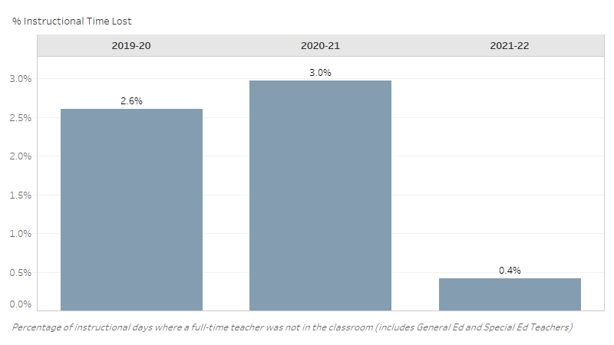
Figure: Teacher Absences and % Instructional Time Lost

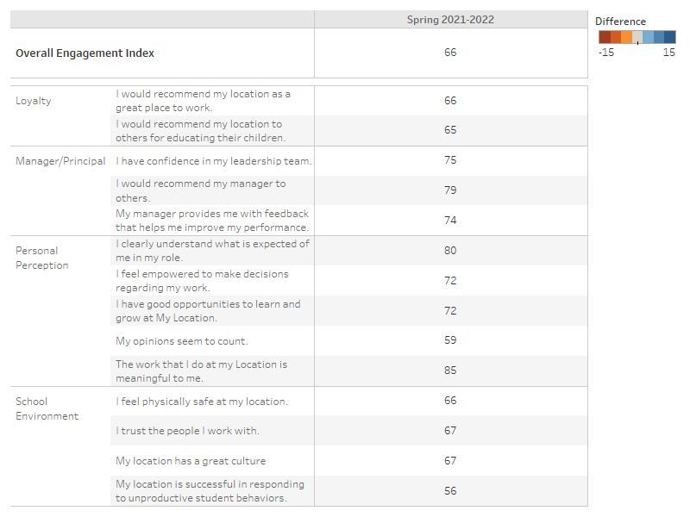
Figure: Staff Perceptions

What trends do you notice in your school staff data?
We have seen a significant improvement in staff data, specifically when it comes to teacher turnover. We decreased from 37% turnover to 10% only losing 4 teachers. The majority of our teachers fall under 3 years experience category with 4 to 8 years experience not far behind. Overall building morale has shown a great improvement and the school as a whole has had significant growth in the area of staff satisfaction and attendance.
Are there action steps you are taking/will take to impact this trend? If yes, what are they?
As a schoolwide effort, the Sunshine committee in conjunction with the School Improvement team will utilize staff data, the Glint survey results and teacher input to continue to retain teachers, improve attendance, and keep morale and satisfaction high.

8.0 Parent Perception Data

Parent perception data is collected in order to provide information on trends in parent satisfaction year over year.
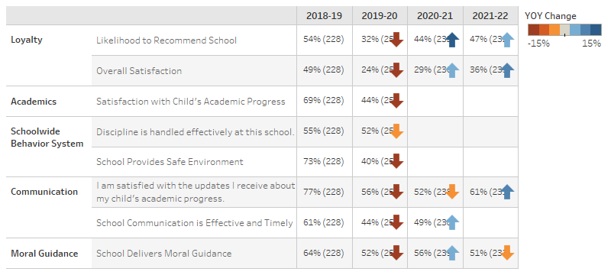
Figure: Parent Survey Results

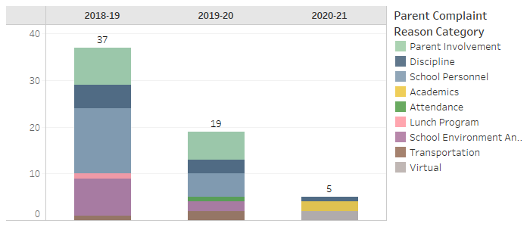
Figure: Parent Complaint Counts

What trends do you notice in your school parent perception data?
Overall parent satisfaction has shown a significant improvement of nearly 30%. Parent complaints have been reduced by 2/3. In addition, parent recommendation, satisfaction with communication, and delivery of moral guidance were also significantly recognized by parents.
Are there action steps you are taking/will take to impact this trend? If yes, what are they?
This year we are increasing the amount of family-friendly events, increasing parent participation, and strengthening our communication with the parents through the use of the parent portal, email, and the Remind app.

9.0 Demographic Data

Student Demographic Data is collected to demonstrate trends in enrollment, attendance, mobility and discipline year over year.
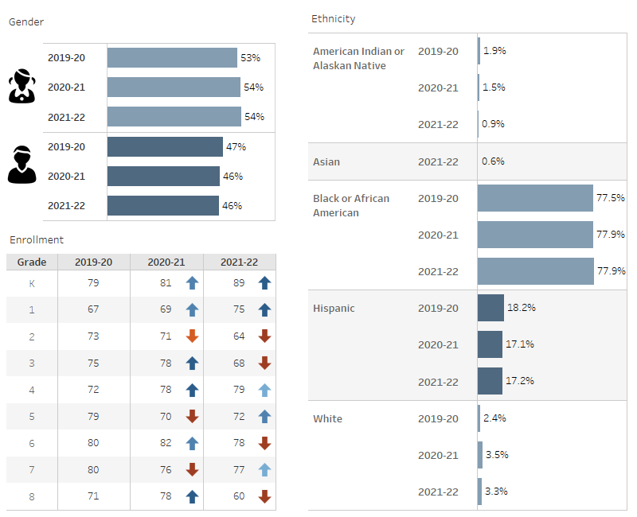
Figure: Gender, Ethnicity, and Enrollment

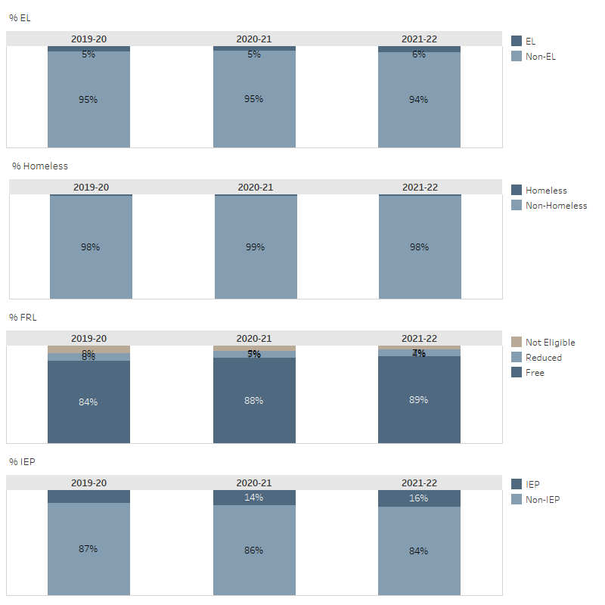
Figure: % EL, % Homeless, %FRL, % IEP

What trends do you notice in your school student demographic data?
Gender remains fairly even at Southside. While African American students have remained consistent, Hispanic students have slightly decreased. Native American populations have slightly decreased over the last year at Southside. Southside’s enrollment has Increased at the Kindergarten, 1st grade, 3rd grade, 4th grade, 6th grade and 8th grade level. Enrollment seems to have decreased at 2nd, 5th, and 7th grade. Free and Reduced Lunch Percentage are at 95%, with 5% students are not eligible for free or reduced lunch out of 684 students. The Special Education Population has increased slightly over the last year. 12% of Southside’s students qualified in the 2020-2021 school year with a total of 85 students receiving Special Education Services. Homeless Students percentage has increased slightly where the number of EL Students has increased slightly over the past year.
Are there action steps you are taking/will take to impact this trend? If yes, what are they?
*State Action Plans for the continued enrollment and Retention of EL students and SWD entails targeting enrollment efforts towards organizations and families that support these two demographics. Southside needs to be more prepared with resources for our students who become Homeless, so support is immediate and not delayed. The school needs to continue to stress the importance of the FRL paperwork and documentation. We will also continue to support and identify through a strong intervention process students who qualify for Special Education. This process will include an early start on identifying students in the high-risk category by using benchmark testing early in the school year, such as IReady, AIMS WEB and NWEA programs. We must continue to utilize our Intervention team to work with our tier 3 and 2 students and submit referrals to SBIT (School Based Intervention Team) Academic team early in the school year. SBIT team will consist of the Dean of Special Education, School Social Worker, and several grade level teachers to review paperwork and cases.

9.1 Student Attrition Data
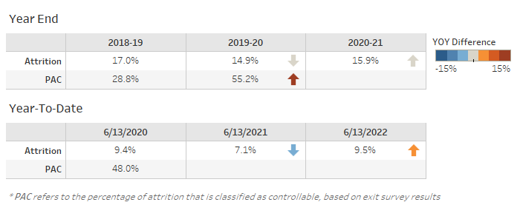
Figure: Student Attrition

What trends do you notice in your school student attrition data?
The end of year attrition data for the 2020-2021 school year slightly increased from the previous school year. At the end of the 2019 - 2020 school year, we were at 14.9% increase to 15.9% at the end of the following year. At the end of the 2019-2020 school year it decreased to 14.9%, which was a 2.1% decrease overall. The percentage of controlled attrition from the end of the 2018-2019 to the end of the 2019-2020 school year increased from 28.8% to 55.2%. Year-to-date attrition increased from 3.8% to 8.2% from the 2019 to the 2020 school year, but did decrease the 4.4% in 2021, as of February 2nd 2021. The percent of attrition that was controllable decreased from 50% in 2019 to 45% in 2020. The increase in percent is due to consistency with both leadership and staff as well as a responsive effort to improve parent involvement and student performance.
Are there action steps you are taking/will take to impact this trend? If yes, what are they?
To impact this trend the school community will continue to reach out to parents and include them in decision making processes. This can include parent meetings, surveys, and providing opportunities where parents can voice their opinions and their concerns. In addition, Southside can continue to provide these opportunities multiple times throughout the year so that parents feel included. Another practice that would be beneficial for the Southside community is to continue to benefit practices and school processes to students, teachers, and parents. Keeping parents informed about school expectations ensures that everyone knows and understands what is expected for success. We can continue to ask scholars, teachers, and parents to sign the Statement of Success document each year, which documents that the expectations were given.

9.2 Student Attendance
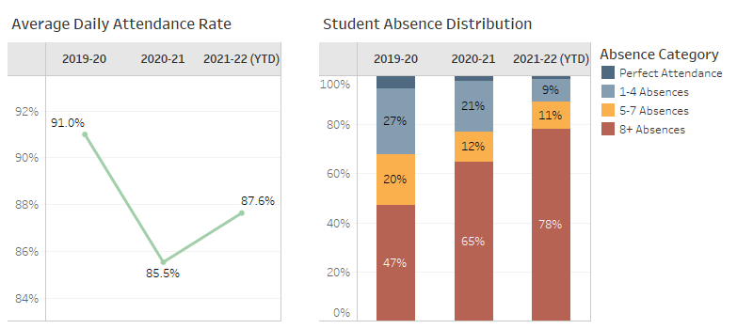
Figure: Student Attendance

What trends do you notice in your student attendance data?
Student attendance has shown a slight increase this year. With the decline of COVID cases and the increase in health and safety attempts by the school, attendance is slowly improving. Perfect attendance has increased to 3% while the percentage of students with more than 8 absences has decreased to 59%. Leadership and staff are very aware of initiatives to improve attendance and the numbers are showing.
Are there action steps you are taking/will take to impact this trend? If yes, what are they?
As a school, we will continue with the comprehensive attendance policy that has been established. There are staff members designated for tracking attendance and contacting families that have frequent absenteeism. Any and all accommodations are made for families to encourage attendance either in person or virtually (if quarantined due to COVID/exposure]) such as delivering Chromebooks, providing hot spots, and making adjustments to bussing/transportation. In addition, our attendance committee monitors attendance daily. Reports are sent out notifying families of truancy and contact is made with the parents. The committee meets to discuss numbers biweekly and work together to develop strategies for improving attendance. We currently offer attendance incentives for students with struggling attendance. This includes money for grade level wings with the most attendance which is used for things for the students. Prize incentives for the students as well from teachers for improved attendance.

9.3 Student Discipline
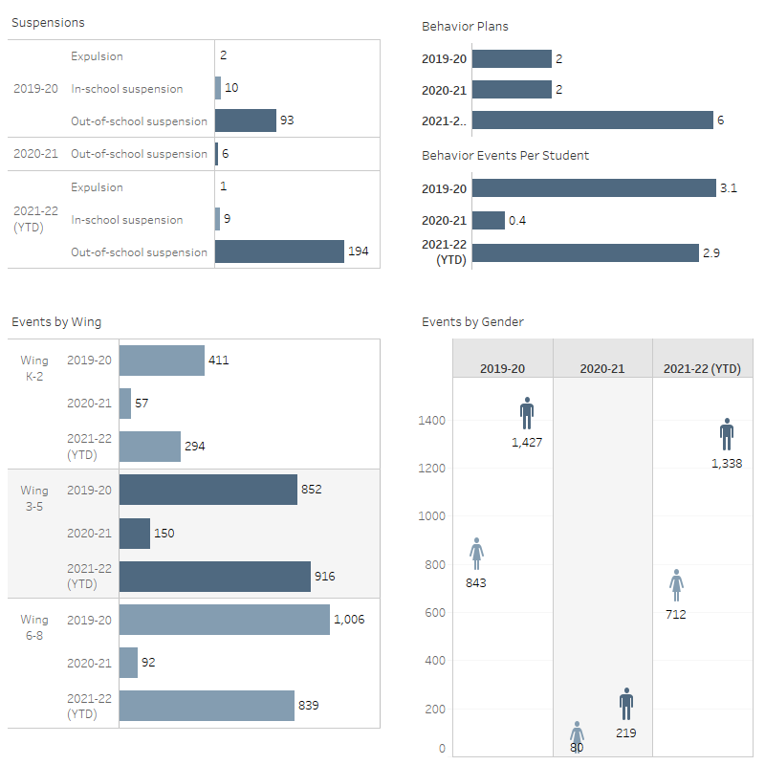
Figure: Suspensions, Events By Wing, Events Per Student, Events By Gender

What trends do you notice in your student discipline data?
With the students returning to in-person learning, the number of behavioral incidences has increased. There has been a significant increase with our middle school scholars from last year with only 92 events to 534 this year. The behaviors have increased for both males and females. In cracking down on behavior, the suspensions have increased in hopes to reach a gradual decrease in behavior. We still currently have two students on behavior plans.
Are there action steps you are taking/will take to impact this trend? If yes, what are they?
The leadership team will provide professional development for staff around behavior management and restorative practices. This will include training on effective behavior management strategies, implementing Behave with Care, and workshops on Restorative Justice and how to apply it in the classroom across the grade level. Teachers will offer mentorship opportunities for students who struggle with behavior. They will offer as a resource for that student to use when having difficulty or as a release. Continue to implement and expand on restorative practices. Teachers and staff will have a school-based intervention committee for behavior to address the needs and provide interventions for students. Finally, explore opportunities for wraparound services to support the mental health needs and the socio-emotional support of our students such as additional counselors, approved mental health programs, and counseling lunch groups. We have updated and retrained staff as well. In addition to providing additional support and training positions.

10.0 School Community Summary

Provide a summary of unique features and challenges associated with the community in which your school resides. Include demographic and economic information.
Syracuse is located close to the center of New York. Syracuse is part of Onondaga County. Syracuse has 25.04 square miles of land area and 0.56 square miles of water area. As of 2010-2014, the total Syracuse population is 144,648, which has shrunk 1.80% since 2000. The population growth rate is much lower than the state average rate of 3.26% and is much lower than the national average rate of 11.61%. Syracuse median household income is $31,566 in 2010-2014 and has grown by 26.26% since 2000. The income growth rate is lower than the state average rate of 35.25% and is about the same as the national average rate of 27.36%. Syracuse median house value is $87,800 in 2010-2014 and has grown by 29.12% since 2000. The house value growth rate is much lower than the state average rate of 90.79% and is much lower than the national average rate of 46.91%. As a reference, the national Consumer Price Index (CPI) inflation rate for the same period is 26.63%. On average, the public school district that covers Syracuse is worse than the state average in quality. The crime rate in Syracuse is higher than the state and national averages. Syracuse is ranked 35th out of 1,142 cities with a poverty rate of 35.1%.

11.0 Student Interim Data
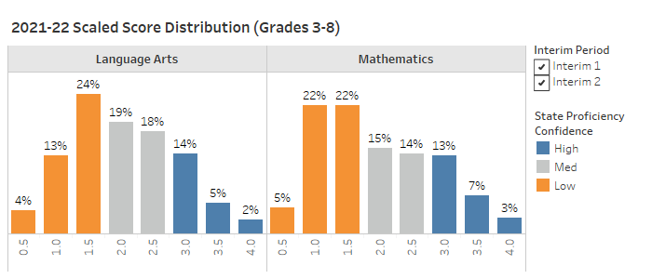
Figure: Interim Scaled Score Distribution

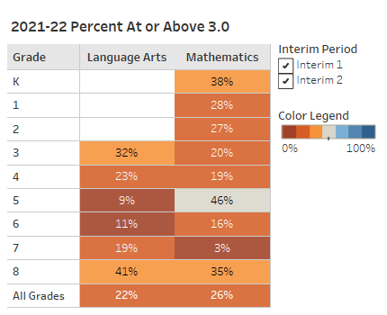
Figure: Interim Percent At or Above 3.0

What trends do you notice in your student interim data?
Students are trending towards the state average and achieved 41% proficient in ELA * 8th grade Math had 42% proficient and is trending toward the state average * Overall the students are trending towards proficiency in ELA with another 22% schoolwide and the second interim should reveal more to be proficient prior to state testing. * After interim 1 in Math, 42% students are proficient with 10% being 5-7 points from proficiency. * Grade 5 and 6 in ELA, as well as grade 7 in math are performing below expected proficiency after interim 1.
Are there action steps you are taking/will take to impact this trend? If yes, what are they?
We will continue to provide increased intervention support to all at risk students. In hopes to grow our medium level students, we will provide additional learning opportunities in our hybrid and virtual models that address utilizes a specific standard focus, Ready NY workbooks, as well as core curriculum materials such as the gaps in their understanding. This includes using Dreambox math, Lexia ELA, small group instruction that Illustrative math and novel study. Teachers will be provided with additional support from interventionist who use Aimsweb data to address proficiency. Interventionist are using intervention strategies, and oral reading fluency checks in order to address the needs of deficient students. Through the continuous analyzing of data points, we will refocus our year long plans and instructional strategies to address the needs of all non-proficient students.

12.0 State Test Data
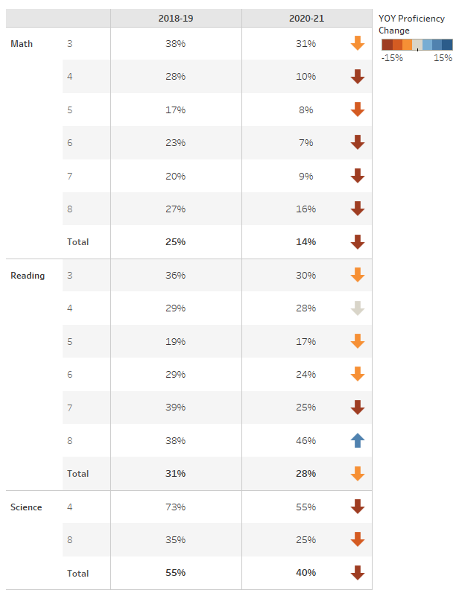
Figure: State % Proficient by Grade

12.1 Subgroup State Achievement Data

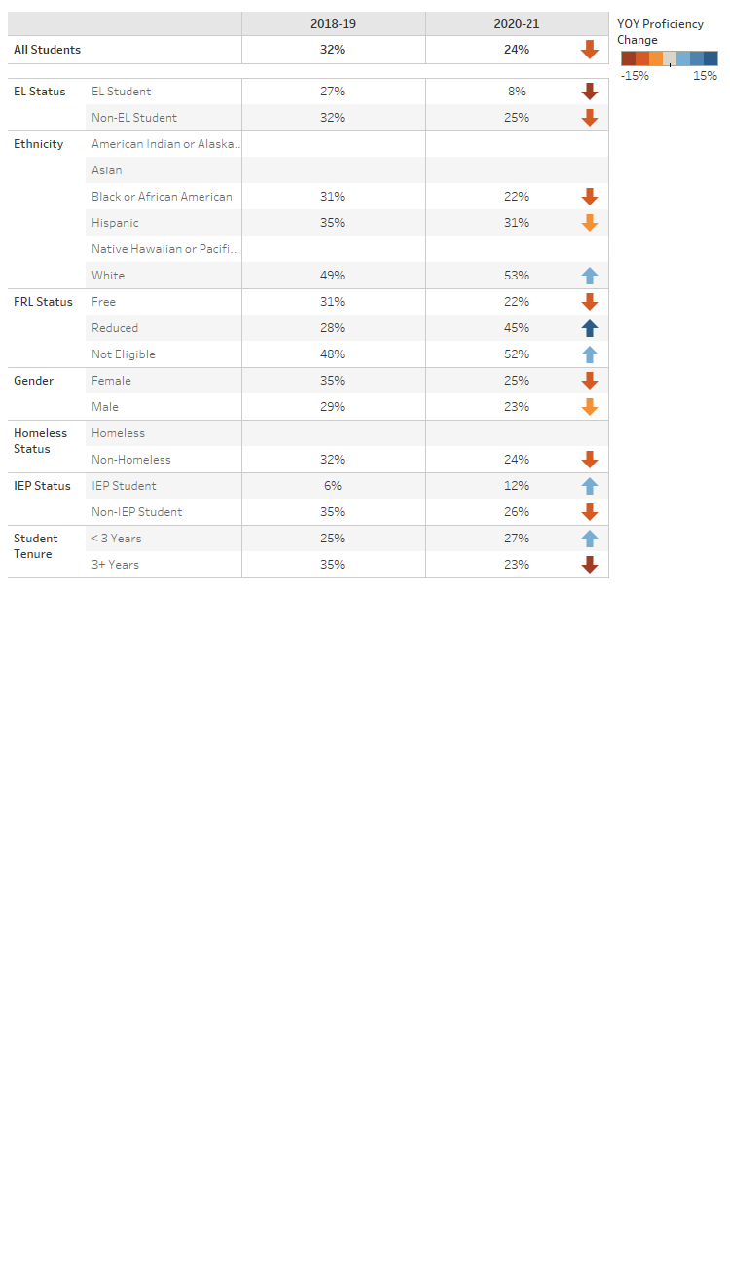
Figure: State % Proficient by Subgroup

What trends do you notice in your student state test data, by grade, by subgroup?
As a whole proficiency has decreased for our testing data. This is in part due to the COVID pandemic and the lack of in-person instruction. If there was any increase in percentages it was a very small and insignificant amount.
Are there action steps you are taking/will take to impact this trend? If yes, what are they?
The school has made a building-wide effort to improve test scores. Test practice and prep, more access to materials, better and more focused curriculum to aid in improvement.

13.0 Comprehensive Needs Summary

Reading
What strengths and challenges in Reading have been identified?
For the K - 2 team, the biggest challenge is how to move scholars towards grade-level mastery and limited interventions. Due to remote learning last year, the learning loss has been significant and we need to address the gap. For the 3 - 5 team, reading challenges include increasing fluency across the board through correct reading instruction. In addition, low comprehension and skill application. For the 6 - 8 team, we identified comprehension and fluency as areas of strength while vocabulary and context clues are areas of weakness.
What trends have been identified in Reading?
A trend in K-2 we are consistently noticing is that scholars are performing/reading below grade level. This is due in part to remote learning and increased learning loss. In grades 3 - 5, our scholars are struggling with retaining information and reading comprehension. They have difficulty applying what they have read to real life situations. For our middle school, scholars typically don't understand the same academic and content-specific vocabulary. Scholars struggle to make inferences when details are implied in the text and lack the ability to connect context clues.
Are there action steps you are taking/will take to impact this trend? If yes, what are they?
K - 2 continues to use/implement the Balanced Literacy program along with Reading Mastery to improve reading skills as well as small group instruction and intervention. 3 - 5 will continue to use intensive corrective reading in addition to comprehension intervention groups. In our middles school, we practice close reading skills with scholars, such as highlighting unfamiliar words, addressing different methods of context clues, margin notes after each paragraph, and active/intentional highlighting.
Writing
What strengths and challenges in Writing have been identified?
There is no set writing program for the K -2 teacher to strengthen students writing skills and therefore teachers are implementing strategies used in the upper grades. Grades 3 - 8 are beginning a new writing program entitled No Red Ink. This is in the beginning stages. Our middle school scholars show strength with identifying text-based evidence, producing original/coherent answers to the question. Some challenges include explaining how details/evidence from the text supports their written answer.
What trends have been identified in Writing?
In K - 2, year after year, the students continue to struggle with basic writing skills. Unable to produce grade-level writing pieces and lack the foundational and mechanical writing skills necessary to be successful. For our 3 - 8 scholars, we find that they are not following the prescribed formula or method for writing (R.A.C.E.S.) Scholars provide the minimum (not enough details, not explaining details, providing a summary statement.) Constructed responses need to be 5-6 sentences and we see a trend of 2-4 sentences with incorrect grammar and mechanics.
Are there action steps you are taking/will take to impact this trend? If yes, what are they?
Our younger scholar would benefit from the implementation of constructed responses for shorter passage practice. The Lexia learning programs increases academic areas of deficiency within each scholar working from their individual level in English Language Arts. In addition to alternating month Bulletin Boards related to the Common Core Writing Standards. For our older scholars, breaking down each step of the process of R.A.C.E.S. Modeling as well as using student models/samples (good./bad) processes. Implementation of the new writing program for all grade levels
Math
What strengths and challenges in Math have been identified?
K - 2 has become more hands-on instruction with the Bridges Program. We have more time for independent practices for workplaces and intervention. The students are still struggling though and have difficulty moving to grade level because they are lacking the fundamental skills necessary to do so. For grades 3 - 5, we have also implemented Bridges in addition to the learning loss curriculum which has begun to help bridge the learning gap. The students are more interactive and hands-on with this curriculum. The concepts are more difficult so it does take longer for mastery. The strengths in middle school math would be the rigorous Illustrative math program that allows students to work in groups, with hands-on materials, to manipulate and discuss strategies of computation. The challenges we face are the gaps in student understanding from lack of a strong foundation in math that would allow them to be proficient in the program, and know when to apply certain strategies when they need to be applied.
What trends have been identified in Math?
Kindergarten through second grade overall math seems to be a strength for the K - 2 students and shows steady growth. Grades 6 - 8 scholars lack the foundational knowledge of performing certain operations and need to be retaught operations such as fractions, adding and subtracting integers, multiplication and division skills, as well as reducing numbers.
Are there action steps you are taking/will take to impact this trend? If yes, what are they?
K - 2: Introduced a new, interactive math program. Increased instructional time for math. Strengthened interventions with a new intervention block. Grades three through five introducing Dreambox of a new math program along with the learning loss curriculum which will help move students to become more proficient and ready for the state testing. Grades six through eight has taken action steps through Dreambox instruction, do now's that address foundational prerequisite knowledge, intervention, and small group instruction.
Science
What strengths and challenges in Science have been identified?
Grades K through 2 do not have an updated science program. The current program we are using is outdated and not interactive. Teachers in first and second grade feel their needs to be a science program that has interactive elements. One that will take advantage of their curiosity and provide them with more science experience. Grade three through five also use an outdated program . Grades six through eight change to online only to PowerPoint and open discussion has increased student participation. Prior to this students were not engaged or willing to participate through google classroom work.
What trends have been identified in Science?
Kindergarten through second grade the students seem to enjoy and want to learn about science but with the lack of an engaging curriculum, this is a struggle. Grades three through five struggle to have student interested and therefore are not engaged. Grades six through eight have increased conversation which has increased engagement among scholars and participation.
Are there action steps you are taking/will take to impact this trend? If yes, what are they?
Kindergarten through fifth grade can research a new curriculum that incorporates a hands on element. Grades six - 8 can increase open ended questions that invite students to actually think about their answers before responding. Also, using photos and reaching students on their levels of learning has increased participation and growth. This year we have also introduced science interim assessments to better understand the students needs.
Social Studies
What strengths and challenges in Social Studies have been identified?
Kindergarten through second grade has implemented a new, interactive curriculum. This program offers different learning styles for the students and is engaging. Grades three through five have no social studies program and focus on current events. Grades six through eighth grade has a unique teaching perspective that engages the students and allows participation through audio and visual instruction.
What trends have been identified in Social Studies?
Kindergarten through second grade has an increase in engagement and participation. Grades three through five need to research a new social studies program that will engage the scholars. Grades six through eighth have an increase in conversation, engagement among scholars, and participation.
Are there action steps you are taking/will take to impact this trend? If yes, what are they?
Kindergarten through second grade will continue with the new curriculum. Grades six through eight will increased open ended questions by using Bloom's Taxonomy to engage all students
Student Interventions
How does your school make sure all students learn at a high level?
We have increased interventions building-wide. Additional intervention time has been built into the schedule and paraprofessionals are being used to support this learning. We continue to use the tiered system of teaching and learning.
How does your school identify students who need intervention?
We monitor through a series of programs including; AIMSweb, NWEA, Dreambox, Lexia and weekly progress monitoring. In addition, teachers identify students based on classroom performance.
How does your school intervene for students who need the most instruction support (both in the classroom and through intervention programs)?
Building-wide we have the Student Behavior Intervention Team which addresses both behavior and academics. The referral process comes from the teacher and is based on student performance and classroom functioning. This process is monitored and led by the leadership team.
How does your school determine if the needs of those students are being met?
Building-wide weekly progress monitor and conduct quarterly benchmarks. Performing weekly data dives to provide weekly monitoring of standards and skill that have been mastered and those that may need to be retaught.
How are your teachers involved in analyzing student achievement data to improve the results of all students?
Building-wide we have weekly data dive meetings where teachers look at benchmark and weekly assessments to plan and adapt instruction.
Highly Qualified Staff
What does your school do to attract and/or retain high quality teachers (different from the things NHA might do on your behalf)?
To attain high-quality teachers we use the local websites to advertise. In addition, hiring within the corporation/transfer from alternate schools is a means to obtain candidates.
Staff Professional Development
What staff development offerings were the most effective last year?
The most effective staff development offerings last year would include new curriculum training including Bridges. Also, we highly benefitted from restorative justice training.
How do you know the PD was effective?
To assess if PD is affected, observe whether it is being used in the classroom. Using teacher observations and evaluations to assess teacher effectiveness. In addition, we can look at student data to assess whether there is successful outcomes/student progress.
How will the learning be sustained moving forward?
For K - 8, we will continually progress monitor our students. Weekly data dives will be held to assess data and identify areas that still need to be addressed for each student based on benchmark and weekly assessments.
What kinds of training or support would benefit your staff this upcoming school year and why?
K - 8 staff benefited from training regarding behavior management and relational capacity during professional development. We also would like to increase attendance incentives and means of improving attendance. Teachers would also benefit from additional professional certification opportunities towards certification hours.
Schoolwide Reform Strategies
The school educational program is grounded in the principles of Effective Schools Research, which was originally developed by Ronald R. Edmonds, who served on the faculties of Harvard University and Michigan State University. Effective Schools Research recommends research-based school attributes that are associated with quantifiably improved student learning. By definition, an “Effective School” is one in which all children obtain at least the essential knowledge, concepts, and skills needed to be successful at the next higher level. Within the Effective School, there are seven unique characteristics that correlate with school effectiveness. The school, a public-school academy, has adopted these characteristics as part of its promise to deliver a high-quality educational option for parents of the community. A summary of the Effective School correlates is as follows: - Clear School Mission - High Expectations for Success - Instructional Leadership - Frequent Monitoring of Student Progress - Opportunities to Learn and Student Time-on-Task - Safe and Orderly Environment - Strong Home-School Relations
In addition to adopting these characteristics of Effective Schools Research, the educational program includes a “Back to Basics” approach, a longer school day, and structured discipline, and the curriculum includes a moral focus component based on the Greek cardinal virtues. The educational program utilizes a curriculum that is scientifically research-based, aligned with State standards, and designed to ensure college opportunity for each child that the school serves.
While Effective Schools Research serves as the foundation of the school’s educational program, it has adopted a number of schoolwide reform strategies to ensure that it: - Provides opportunities for all children to meet the State’s proficient and advanced levels of student academic achievement; - Uses effective methods and instructional strategies that are based on scientifically-based research; and - Addresses the needs of all children in the school, but particularly the needs of low-achieving children and those at risk of not meeting the State student academic achievement standards.
One research-based schoolwide reform strategy that the school has adopted is the utilization of a master schedule that provides teachers with opportunities to differentiate instruction in order to meet the varied learning needs of students. According to Tomlinson and Eidson, differentiated instruction “refers to a systematic approach to planning curriculum and instruction for academically diverse learners” and is “a way of thinking about the classroom with the dual goals of honoring each student’s learning needs and maximizing each student’s learning capacity” (2003). The school uses differentiated instruction by implementing regularly scheduled workshop sessions and flexible grouping in order to meet each student’s individual learning needs. The school believes that “only when a student works at a level of difficulty that is both challenging and attainable for that student does learning take place” (Tomlinson, 2003). As such, the school employs differentiated instruction in order to address the needs of all children in the school—particularly those at risk of not meeting challenging State standards.
Another research-based schoolwide reform strategy that the school has adopted is the development of what Richard DuFour calls a Professional Learning Community. Specifically, the school has worked to develop a teaching environment in which all teachers work together to ensure that students learn, where collaboration among teachers is prevalent, and where there is a focus on student learning and results (DuFour, 2004). The school has adjusted its class and teacher schedules to ensure that grade-level teachers share a common planning time in which each member of the instructional team participates in dialogue about student learning and develops strategies to improve both teaching and learning. Mike Schmoker, a leading school improvement thinker, has argued that professional learning communities “feature the most powerful set of structures and practices for improving instruction” (2006). With this in view, the school has implemented these research-based professional learning communities to ensure that teachers are using effective methods and instructional strategies, thereby meeting the needs of all students.
In addition to utilizing differentiated instruction and implementing professional learning communities, the school has also adopted a system that ensures that teachers and students can establish and communicate about student learning goals and track student progress through the formative assessment process. Research supports these schoolwide reform strategies. Specifically, research has demonstrated that “goal setting has a general tendency to enhance learning” (Marzano, 2007). As such, the school believes it is imperative to identify student learning goals, or educational objectives, so that teachers and students can gauge learning with respect to those goals and celebrate student success that they make progress toward mastery. Importantly, because the school is utilizing specific student learning goals- which align with all applicable Department of Education guidelines- teachers can effectively provide feedback on student learning through the use of formative assessment. Marzano points out that “major reviews of research on the effects of formative assessment indicate that it might be one of the more powerful weapons in a teacher’s arsenal” (2007). W. James Popham describes formative assessment as “a planned process in which assessment-elicited evidence of students’ status is used by teachers to adjust their ongoing instructional procedures or by students to adjust their current learning tactics” (2008). Since teachers of the school have well-established student learning goals, they are able to utilize the formative assessment process to track student learning, gauge progress toward mastery, adjust instruction accordingly, and celebrate student success as it relates to learning. Indeed, the employment of these research-based strategies ensures that all students are given the opportunity to learn and succeed in the school’s classrooms.
Finally, the school has adopted as a schoolwide reform strategy the delivery of additional opportunities to learn for students who need to grow in their background knowledge. In Marzano’s seminal meta-analysis of research on school-, teacher-, and student-level factors that impact student achievement, the author argues that there is a strong correlation between background knowledge and student achievement. Where students do not have background knowledge sufficient to ensure academic success, the school works to provide increased opportunities for students to enhance their background knowledge so that their learning can be accelerated; such opportunities may include tutoring, mentoring, vocabulary instruction, and other interventions that ensure students have increased time to learn the knowledge and skills they need to be academically successful. The school’s foundation of Effective Schools Research, coupled with these comprehensive schoolwide reform strategies, is the means by which it ensures that all children are academically successful. Indeed, these strategies enable the school to provide opportunities for all students to progress toward and demonstrate proficiency, and to also ensure college opportunity for each student the school serves.
With these strategies in mind, the school has developed a number of goals to support its effort to ensure that all the school’s students succeed and are able to master State standards. These goals are outlined in the following section of this plan.
Instruction by Highly Qualified Teachers
The school has adopted a hiring practice that requires all new and existing teachers to meet the “highly qualified” requirements as outlined by Every Student Succeeds Act of 2015 legislation. The academy’s management company, National Heritage Academies, tracks teacher qualification status and ensures that teachers achieve and maintain the correct qualifications. All teachers are provided with a fifty percent (50%) tuition reimbursement to either achieve or maintain highly qualified status.
All teachers are currently highly qualified. The school has developed a plan to ensure that it complies with the applicable section of the Every Student Succeeds Act of 2015. The plan outlines the means by which 100% of the school’s staff will reach highly qualified status by the close of the school year.
Strategies to Attract High Quality Teachers
The school will continue to monitor its teacher-turnover rate in order to maintain its commitment to attracting and retaining high-quality, highly qualified teachers. The school will continue to monitor its teacher-turnover rate in order to maintain its commitment to attracting and retaining high-quality, highly qualified teachers. The school holds as a top priority the recruiting, hiring, and retaining of high quality, highly qualified, and fully licensed teachers to serve its students. Efforts made by the school and its management partner, National Heritage Academies, include the following: - Establishing close relationships with local universities and colleges with teacher education programs. - Yearly attendance at college teacher specific job fairs. - Internal teacher job fair events sponsored by National Heritage Academies. - Advertising positions through online college postings, newspaper advertisements, the National Heritage Academies website, and a weekly internal job newsletter that is sent out to all school and NHA employees. - Offering a competitive salary and benefits package, including fifty percent (50%) reimbursement benefit for continuing education. - Providing a comprehensive orientation that facilitates a successful transition into teaching. - Providing opportunities for teachers to improve their instructional skills through a comprehensive professional development program. - Including teachers in the continuous improvement planning process, and other school initiatives and activities.
The school has developed a plan to ensure that it complies with all applicable sections of the Every Student Succeeds Act of 2015. Research indicates that one of the most significant initiatives schools undertake to retain staff is to create a team-based collaborative culture within the school. The focus at the school on grade level teams and on having teachers as active members of the improvement team, serves to ensure that the school achieves greater consensus, collaboration, and cooperation throughout the school. This should be an asset in ensuring that the teacher turnover rate remains low.

14.0 Wellness Policy and Goal Evaluation

The National School Lunch Act mandates that all schools participating in the National School Lunch Program and/or School Breakfast Program establish a Wellness Policy and general requirements for the development, implementation, dissemination and assessment of the policy and evaluate it annually.
Has progress been made on the Wellness Goals?
Yes, progress has been made on Wellness Goals: Students are able to use the gym for classes, sports and extracurricular activities. Healthy snack day in March let the students try healthy snacks: fruits and vegtables etc. which will help them make smarter choices.
Do you think the Wellness Policy and goals are positively impacting student wellness, nutrition, and regular physical activity?
Yes, the students are more active which improves there overall wellness: Physically, mentally and socially. Students will make healthier choices for nutrition if they are more active.
In your opinion, does the Wellness Policy need to be changed? If so, what would you change?
The Wellness Policy in place is a good start. Students are given brain breaks with fitness activities in class, recess, regular physical education, and after-school sports. Healthier snacks and lunch choices is an ongoing process. We would enhance the program with some of the following adding in Fitness Brain Breaks throughout the day. In addition, students will be more active in the classroom, especially during transition times. Water breaks will be factored into the schedule in addition to offering healthier lunches and snack choices. Students would also benefit from healthy choices handouts, posters, assignments, and extracurricular activities.
What changes, if any, do you think are necessary to be made to the Wellness goals?
More after-school and summer recreation/sports programs for the scholars. Build on the current after-school sports: volleyball, track, etc... We will begin assisting students with making healthier food choices and adding more daily activities throughout their day.

15.0 School Improvement Goals
Action Plan for Continuous Improvement
Goal | Reduce the number of suspensions
Baselne Data | As of March 7, 2022 we had 74 out of school suspensions
Area of Need | Social-Emotional
Root Cause
Strategies
Activities/Action Steps the School will Implement as Part of the Overall Strategy for Continuous Improvement and Meeting Goal/Objective.
Name | Activity Type | Action Steps | Begin Date | End Date | Staff Responsible | Funding | Measurement of Progress | Goal Status | Notes
Two full time ABSS positions |  |  | February 2022 | ongoing | Principal | ESSER | Out of School suspension by March 2023
PD (ex. Capturing Kids Hearts) |  |  | August 2022 | 2022-23 School year | Principal |  | Out of School suspension by March 2023

Goal | Decrease failure rate by 10% on ELA and Math Interim assessments
Baselne Data | 76% failure rate in ELA on Interim 2.77% failure rate in Math on Interim 2.77% failure rate in Math on Interim 2.
Area of Need | Academic
Root Cause
Strategies
Activities/Action Steps the School will Implement as Part of the Overall Strategy for Continuous Improvement and Meeting Goal/Objective.
Name | Activity Type | Action Steps | Begin Date | End Date | Staff Responsible | Funding | Measurement of Progress | Goal Status | Notes
We will use digital versions of math and ELA programs for increase personalization of instruction and to augment and increase frequency of small group targeted skill lessons. |  |  |  |  | Teachers |  | 2023 Interim 2 results
We will continue using AimswebPlus for progress monitoring for all K-2 students and for ELL and special education students in grades 3-8. We also use this tool to measure the progress of all students in the bottom quartile in all grades. The program will support school efforts in screening, progress monitoring, and data management |  |  |  |  | Teachers |  | 2023 Interim 2 results
Through Data Analysis, staff will make data driven decisions when address academic needs of our scholars |  |  |  |  | Teachers & Deans |  | 2023 Interim 2 results

16.0 Evaluation of School Improvement Efforts

How does your school evaluate the effectiveness of your goals and strategies each year?
The administrative meet several times a week to review overall school data. The wing meetings are meeting weekly during a data dive. This process continues to be enhanced throughout the year. Staff utilized NWEA, interim assessments, and AimsWeb to track student progress and plan for reteaching. The team also evaluates the use of the interventionists to best meet the needs of at-risk students.
In reviewing the goals from last year's SIP, provide an overview/evaluation of progress made toward those goals. Was progress made toward accomplishing the goal? If so, will you a) Continue the goal? b) Discontinue the goal, if so why?
As a whole, we have made steady progress towards our goals. Leadership, staff, students and families have made a consistent and collaborative effort to improve the overall school performance and areas of need.

17.0 Professional Learning Plan

In accordance with ESSA, the academy provides high-quality and ongoing professional learning for teachers, principals, and paraprofessionals and, if appropriate, pupil services personnel, parents, and other staff to enable all children in the school to meet the state's student academic achievement standards.
The school plans to carefully integrate its professional learning for the staff—for both teachers and paraprofessionals—into its collaborative team-focused culture and its ongoing teacher supervision and support model. The cornerstone of that model is the grade level team arrangement which provides daily opportunities for common planning/professional learning time for the grade level teams within the regular school days as well as regularly scheduled vertical house/full faculty meetings outside of the school day.
Consider the data you have gathered and carefully identify and prioritize your professional learning needs.
Date | Content Hours | Title | Objectives | PD Type (Required, Grants, or General Funded) | # of Estimated Attendees | Intended Audience

18.0 Community Partnerships

The school utilizes a variety of partnerships to support staff, students, and parents. The school employs an Admissions Representative who works in partnership with the community to organize events, fundraisers, and charity events, as well as to inform the media and local community of school events. Additionally, the school partners with area organizations or community members in order to promote a symbiotic relationship between itself and the community.
Please complete the sections below for each partnership that your school has developed and include specific details as appropriate.
Partner Name | Benefits of Partnership
Montezuma Audubon | Montezuma Audubon has provided onsite activities such as planting gardens at the school and off-site educational opportunities at refuge site for our students in grades k - 8.
The Museum of Science and Technology(MOST) | Staff from the MOST have come and discussed opportunities with our students. Our robotic team also competes in yearly MOST robotics competition.
Syracuse Ballet | Syracuse City Ballet is a professional ballet company in CNY committed to bringing the transformative experience of dance, specifically ballet to the city. The company employs professional dancers from Syracuse, across the United States and the world.
Syracuse Chess Club | Southside's Chess team holds weekly meetings and compete in chess competitions sponsored by Syracuse Chess Club.
Syracuse Police Department | The Syracuse Police Department provides assemblies to raise awareness about bullying to our students. They also utilize the building to proved summer programs for our students. In addition, police presents at the beginning and end of they day is provided.
Syracuse Fire Department | The Syracuse Fire Department provides assemblies and educate our students in fire prevention. They also run a yearly chess tournament with students.

19.0 Parent and Family Engagement Plan and Activities Calendar

The school believes that parents are an integral part of the school and student success. As such, the school has designed a governance structure and parental engagement activities in order to ensure that parents participate in the activities of the school. The school desires parents to be engaged in their child’s education, and the partnership of parents, students, and teachers within the school promotes an optimum learning environment to ensure success. The school’s Parent and Family Engagement Policy and the Parent-Student Compact agreement are used in the school’s Title I program to ensure that parents have the opportunity to provide input in Title I programming and participate in the improvement process. The school’s parents are also asked to complete the school’s Annual Title I Parent Survey; information from that survey is reviewed as part of the school’s comprehensive needs assessment and the evaluation of the school’s Schoolwide Plan.
In accordance with ESSA, the school reviews and distributes the Parent-Student Compact to parents during parent-teacher conferences, during which time the compact is discussed as it relates to individual student performance and the participation and commitment of the parent, teacher, and child in the child’s education.
Complete the chart below by listing details for your planned parent events next year.
Month | Engagement Activity
September 2022 | Title I Parent Meeting (includes review/feedback of School Improvement Plan, Parent Involvement Policy, Commitment to Excellence Contracts, Homeless Dispute Resolution and Title I programming)
October 2022 | Title I Parent Learning Event (i.e. Reading Night, Math Night, etc.)
November 2022 | Fall Parent/Teacher Conferences (includes review of Commitment to Excellence Contracts)
March 2023 | Parent SIP Meeting
April 2023 | Spring Parent/Teacher Conferences
February 2023 | Black History Fashion Show
March 2023 | Literacy Night

Through these activities and parental/family engagement components, the school assures that it appropriately: 1) provides assistance to parents/families; 2) provides materials and training to help parents/families work with children to improve their achievement; 3) trains teachers and other required staff in the importance of and how to partner with parents/families; 4) coordinates and integrates to the appropriate degree its parent and family engagement activities with other programming; 5) communicates information related to school and parent programs and activities are communicated in an understandable format and language; and 6) provides full opportunities for parents/families with limited English proficiency, disabilities, and parents of migratory children to be involved in the activities of the school and to receive appropriate information and school reports. As such, it complies with ESSA.
Parental and family engagement activities, and the parent/family engagement component of this schoolwide plan, will be involved in the annual evaluation of the schoolwide plan. Feedback from parents provided through communication and their participation in the evaluation process will be incorporated into the review process and the school improvement plan and programs will be adjusted accordingly.
Additionally, results of individual student academic assessments will be discussed with parents regularly and, as appropriate, will be shared in a language that parents/families can understand. As such, the school complies with Section 1113(b)(3).
Preschool Transition Strategies
The school is committed to connecting with preschool age children in order to prepare them for school and has developed preschool transition strategies to ensure that incoming students are well-prepared for kindergarten.
Specifically, the school has a dedicated Admissions Representative who works with area preschools, daycares, Head Start programs, etc., in ensuring kindergarten readiness. The school’s Admissions Representative and Administrators meet with community members and preschools to discuss Preschool Transition. Meetings consist of informing parents about the school, inviting parents and students to visit the school and kindergarten classrooms, inviting preschool/daycare staff to visit the school and the kindergarten classrooms, and a training/delineation of information regarding the skills and knowledge students will need to know when they enter the kindergarten classroom. Training/informational packets, which are delivered to parents and area preschools/daycares, contain information about kindergarten readiness, activities to prepare children for kindergarten, and commonly asked questions regarding the transition from preschool to kindergarten.
Further, open-house meetings and events are held at the school over the course of the year in order to encourage area parents and preschoolers to spend time at the school. Kindergarten teachers meet with parents and students, explaining some of what parents and students should expect as the children make the transition into kindergarten.
Teacher Participation in Making Assessment Decisions
Teachers at the school play an active role in making assessment decisions for their students. Specifically, teachers choose to implement as appropriate tests and assessments that measure student performance with respect to the school’s curriculum. Through the formative assessment planning process, teachers work collaboratively with respect to the curriculum in order to identify what specific knowledge or skills students need to know and also to identify how they will determine when such learning has taken place. Teachers participate in the decision-making process regarding whether they use curricular program assessments, common grade-level assessments, or other formative or summative assessments to determine or gauge student learning on an ongoing basis throughout the year. Instruction is adjusted accordingly by each teacher as they work to ensure mastery is attained by each student within their classroom and at the school.
Additionally, schools administer the NWEA assessment. After the NWEA testing period, grade level teams analyze and interpret NWEA data in order to identify areas of strength and areas for improvement with respect to their students. These activities support the school’s overall school-wide student achievement goals (as outlined above) and are used to drive classroom instruction. Teachers create formative and summative assessments to gauge students’ progress regarding these areas for improvement. During common planning time, teachers discuss and analyze assessment data and determine the degree to which students have mastered the content that has been taught.
Assistance to Students Having Difficulty Mastering Standards
The school has implemented activities to ensure that students who experience difficulty mastering standards are provided with effective and timely additional assistance. Additionally, the school has developed measures to ensure that students' difficulties are identified on a timely basis in order to provide teachers and school leadership with sufficient information on which to base effective assistance.
As noted above, teachers utilize formative assessment to meet the varied learning needs of students. The school uses differentiated instruction by implementing regularly scheduled workshop sessions and flexible grouping in order to meet each student’s individual learning needs. The school believes that “only when a student works at a level of difficulty that is both challenging and attainable for that student does learning take place” (Tomlinson, 2003).[1] As such, it employs differentiated instruction in order to address the needs of all children in the school and particularly those at risk of not meeting challenging State standards. As part of this differentiation, teachers use the formative assessment process to ask and answer these questions: 1) What do we want each student to learn? 2) How will we know what each student has learned? and 3) How will we respond when students have difficulty learning? By answering these questions collaboratively, teachers ensure that appropriate intervention is delivered to students who are having difficulties mastering challenging state standards.
Beyond this, the school’s instructional staff collaborates with its Interventions Assistance Team (IAT), which works to identify students having academic or behavioral difficulties. Students who are in danger of having difficulty mastering the State’s academic achievement standards are first identified by the individual teacher’s assessment process, and then students are referred to the IAT. Classroom teachers are provided by the IAT with suggested intervention strategies to implement with individual students. Such strategies sometimes include, but are not limited to: - Adapting time allotted for learning task or completion of assessment - Adapting the number of items that the learner is expected to complete or learn - Adapting the goals or outcome expectations while using the same materials - Adapting the way instruction is given to the learner. For example: visual aids, hands on activities or cooperative groups.
Teachers log interventions used with the individual students and share the results with the school’s IAT team as appropriate.
Additional supplemental interventions are offered for at risk students. Some of these supplemental interventions may include: - Supplemental Staffing (i.e. paraprofessionals, academic specialist, and social worker). - Supplemental subscriptions (BrainPop, Study Island, Accelerated Reader) for intervention programming. - Extended Learning Opportunities, including summer learning programming and before school tutoring. - The use of researched-based, formative assessment to track and analyze individual student progress and drive instruction that is aligned with highly specific reading curriculum, state content standards and grade-level expectations. - Keep track of students’ progress, at least every two weeks, in specified classes - Monthly examination of student work by classroom teacher related to classes. - The use of Formative Assessment to plan instruction that will target areas of weakness, proficiency and mastery.
Coordination and Integration of Federal, State, and Local Services and Programs
The school ensures that the use of all federal, state, and local funds is coordinated to ensure focus on the goals, strategies, and action activities identified in this Schoolwide Plan. Furthermore, coordination and integration of all federal, state, and local services and programs are ensured through collaboration among administration, staff, parents, and other stakeholders as part of the school’s improvement planning process. Specifically, the school utilizes funds from State and local sources, as well as federal sources—including Titles I and IIA—to support the goals identified in the Schoolwide Plan. While funding will not be consolidated, the school’s entire educational program is supported by the school’s Schoolwide Plan; this includes the school’s general educational program (State and local funds) as well as supplemental programs (supported through federal Title I funds). The school’s professional development program, supplemented with funding available through Titles IIA, is also supported by the academy’s Schoolwide Plan. Although the school is not required to delineate the funds that it is consolidating or the specific amounts contributed by each source—because it is not actually consolidating funds—please see the table below for a summary of the resources available to the school and the degree to which they support the components within this Schoolwide Plan.
Since the school is a single school K-8 public school academy, it does not currently apply for or receive violence prevention funds, housing program funds, Head Start funds, adult education funds, vocational and technical education funds, or job training funds. If the school receives these funds at any point in the future, their use will be coordinated along with all other available funds through the school’s Schoolwide Plan.
While the school receives funds through the National School Lunch Act / Child Nutrition Act, their use is not coordinated under this plan as they do not contribute directly toward upgrading the school’s educational program.
Curriculum Alignment
The school implements the National Heritage Academies Curriculum. National Heritage Academies is the school’s management company and has gone to extensive lengths to create a guaranteed and viable curriculum. NHA has researched the level of knowledge and skills students must have to be successful in terms of mastering State standards as well as being prepared for a challenging college program. This has included analyzing data from the NAEP (National Assessment of Educational Progress), ACT (American College Testing), and Northwest Evaluation Association’s (NWEA) in order to determine what students must know in order to be successful in college. By understanding the required knowledge base to succeed at the college level, NHA was able to work backwards and breakdown this knowledge base at each grade level. This breakdown allows for a seamless building of knowledge which will best prepare our students for high school and college. They utilized these findings and state standards to create the curriculum, ensuring the curriculum is aligned to and meets state requirements.
Additionally, the refinement of the curriculum was completed in collaboration with Dr. Robert Marzano and Associates and teachers are working toward the full implementation of formative and summative assessment as proposed by Dr. Marzano.
While the school utilizes the NHA Curriculum to guide instruction, it also understands how that curriculum aligns with State content standards. When the State’s content standards require students to demonstrate knowledge or skills beyond or different from the NHA Curriculum, the school utilizes supplemental curricular tools and resources to ensure that students are fully equipped to demonstrate mastery according to the State’s expectations.
Methods of Effective Use of Technology
The school utilizes technology in a variety of ways to support student learning. Some of these may include Accelerated Reader, Lexia, Brian Pop and Raz Kids, which are each used to improve the academic achievement of all students. Additionally, the school uses myNHA to record attendance, discipline reports, and grades to inform instruction and remediation. All staff and students have internet access in order to research educational topics and ensure technology proficiency among students. Likewise, all staff members communicate via e-mail and voicemail to increase parent awareness and student progress.
On-the-Job Learning
Since the school is a K-8 school that emphasizes a “back-to-basics” curriculum, on-the-job opportunities in a career sense are limited. However, the school does have a strong character education or moral focus component within its curriculum, and in that context, students are expected to serve others via specific service projects that are undertaken at each grade level. Additional on-the-job learning opportunities include: - Safety Monitor - Crossing Guard - Peer Mentoring - Junior Achievement - Career Day - Student Government - College and Career Fair
Building Level Decision Making
Decision Making Process:
Decision-making authority within the school lies with the school’s leadership team, although the school values and considers the input and perspective of staff and stakeholders as decisions are made. Each staff member and stakeholder’s input is valuable, and decisions become effective only once consensus is achieved among them. Decisions support the vision and purpose of the school, National Heritage Academies, and also the best practices of school improvement research and effective teaching strategies. Staff members and stakeholders participate as appropriate as members of the school operating committees in partnership with the parents.
Job Description of the School Improvement Team:
The school has a School Improvement Team that is responsible for the school improvement efforts of the school. Its job is to conduct the school’s comprehensive needs assessment, analyzing student and other data in order to establish appropriate goals and strategies to reduce achievement gaps as identified in the annual gap analysis and adequate yearly progress reviews. The School Improvement Team also reviews and assists in the development, implementation, and evaluation of the following school improvement components: - Annual review of the Building Mission Statement - Building goals, strategies, and assessments based on academic standards for all students - Curriculum alignment with State Standards and Benchmarks, NHA Curriculum, and Core Knowledge objectives - Monitor and evaluate the process for the building school improvement plan - Building professional development plans consistent with student academic performance needs - The utilization of community resources and volunteers - Participatory decision-making process - Identifying community resources that enhance instructor and student learning
The School Improvement Planning Team meets regularly to assess progress on and accomplishment of goals and implementation of the various components of the Schoolwide Plan.

